**INTI International College Penang School of Engineering and Technology 3+0 Bachelor of Science (Hons) in Computer Science, in collaboration with Coventry University, UK 3+0 Bachelor of Science (Hons) in Computing, in collaboration with Coventry University, UK**

**Coursework cover sheet**

**Section A - To be completed by the student**

| Full Name:KEVIN GOH WING CHIEN | |
| --- | --- |
| CU Student ID Number:13446927 | |
| Semester: January 2023 | |
| Lecturer: Shahriman Mohd Said | |
| Module Code and Title: A101SGI Smartphone Apps: From Concept to Design and Market | |
| Assignment No. / Title: REPORT | 100% of Module Mark |
| Hand out date: 9th January 2023 | Due date: 20th February 2023, via Canvas, by 11.59pm. |
| Penalties: No late work will be accepted. If you are unable to submit coursework on time due to extenuating circumstances, you may be eligible for an extension. Please consult the lecturer. | |
| Declaration: I/we the undersigned confirm that I/we have read and agree to abide by the University regulations on plagiarism and cheating and Faculty coursework policies and procedures. I/we confirm that this piece of work is my/our own. I/we consent to appropriate storage of our work for plagiarism checking.  Signature(s): *KEVIN-* | |

**Section B - To be completed by the module leader**

| Intended learning outcomes assessed by this work:   1. Explain and apply key concepts, development methodologies and programming environments for different Smart phone platforms 2. Generate a specification for the design, development and implementation of an APP for a Smartphone 3. Plan a route to market and outline a business case for a mobile APP across relevant platforms | | |
| --- | --- | --- |
| Marking scheme | Max | Mark |
| 1. Individual Report | 20  20  20  20  20 |  |
| a. Business Opportunity |
| b. Marketing and Sales |
| c. Platform Analysis |
| d. Design |
| e. Technical Understanding |
| Total | 100 |  |
| Lecturer’s Feedback  Internal Moderator’s Feedback | | |

**Introduction**

The recent Covid-19 pandemic not only had taken its toll on human lives, it also had affected the country’s economy and the day-to-day activities of citizens in Malaysia. As the pandemic is receding, the government has removed the movement control order (MCO) in an attempt to set the country’s economy back on track. The reopening of businesses has resulted in an increase in job opportunities. While there are a lot of online employment applications that cater to full-time jobs, only a handful of them actually assist job seekers to find part time jobs. Most part time vacancies still employ the walk-in interview method which may not find the optimal match between the quality of labor and wages. The void in such a niche market not only represents an opportunity for business, it is also an innovative way to put one of the country’s most important resources into good use.

Grind is a mobile application that will streamline the process of part time employment. The application will only focus on its niche market and act as a middleman between businesses and the part time labor force. Employers may utilize the application to find the best value for money labor to fill up its vacancies. On the other hand, high quality labor shall be rewarded with higher wages. The vision of Grind is to become a marketplace for part time labor that offers the optimal wage for the quality of service. In order to achieve that, a review and verification service will be provided to both parties so that a best match could be obtained.

**Problem Statement**

More often than not prospective part time employees are not fully aware of the best deals that can be offered to them; The same goes to the employers as well. This usually causes a mismatch between quality of labor and wages. It is believed that higher quality of labor should go to those businesses that are more productive so that an optimal situation for both parties can be achieved.

Even with the advancement in technology, some of the businesses in Malaysia are still only using banners to advertise their vacancies. While there is nothing fundamentally wrong with such a recruitment technique, however it provides a relatively lower audience outreach. Potential candidates are essentially limited to a particular geographical location.

Unlike full time jobs where the human resource team is dedicated to verifying an employee’s track record, most employers of the part time counterpart simply do not have the luxury to do so. On the other hand, small scale businesses such as the hawker stall do not even have a medium for employee review. The lack of a review system allows both parties to shrug from responsibilities and accountabilities.

**Business Opportunity**

The Bottom Line

The figure below shows the interest rate of various maturities for a Malaysian bond on 20th of February 2023. The government bond is a virtually risk-free investment and indicates the bottom-line for the return of any other investments (Scott et al., 2017). The rationale is that the return of the investment in this application should be greater than what the Malaysian bond provides in order to compensate for the risk.

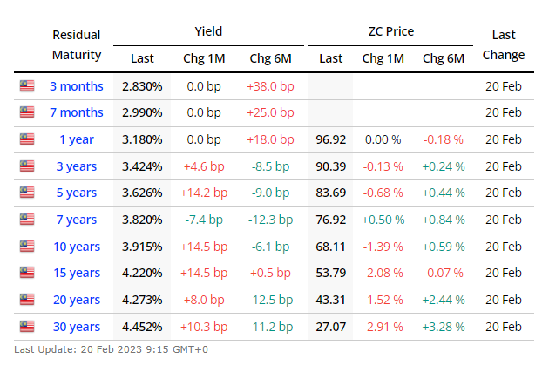

Figure 1.0: (Malaysia Government Bonds - Yield Curve, 2023)

Market Share Analysis

Based on Figure 1.1 below, Malaysia's part-time employment percentage hovers around 11% to 13% of the total employment for the past decade. Since an average of the percentage could not be obtained due to some missing data in the year 2017 and 2018, 12% shall be taken as an approximation for today’s market share.

The first schedule of Employment Act 1955 defines a part time employee as a person who works more than 30% but less than 70% of the normal hours of a full time employee. According to the Department of Statistics Malaysia (2023), around 16.05 million Malaysians are employed for the quarter ending in September 2022. This translates into an approximate of 1,926,000 Malaysians working a part time job.

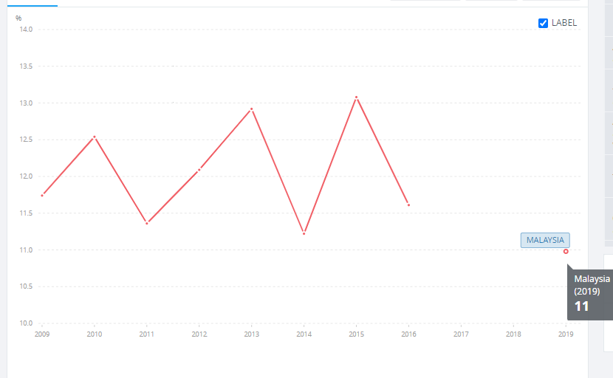

Figure 1.1: (Part Time Employment, total (% of total employment) - Malaysia, 2022)

Empirical Survey

A sample survey had been conducted on students of Inti International College Penang and Politeknik Tun Syed Nasir Syed Ismail to have a better understanding of the current situation. The selection of the participants is done through stratified random sampling. Six INTI students and six Politeknik students, each of equal distribution of genders, are selected randomly to conduct the survey. The reason for such a selection is to avoid selection bias coming from income groups and gender.

Findings: Almost two-thirds of the participants have had a part time job. The top three most popular job-seeking applications are JobStreet, LinkedIn and Indeed.

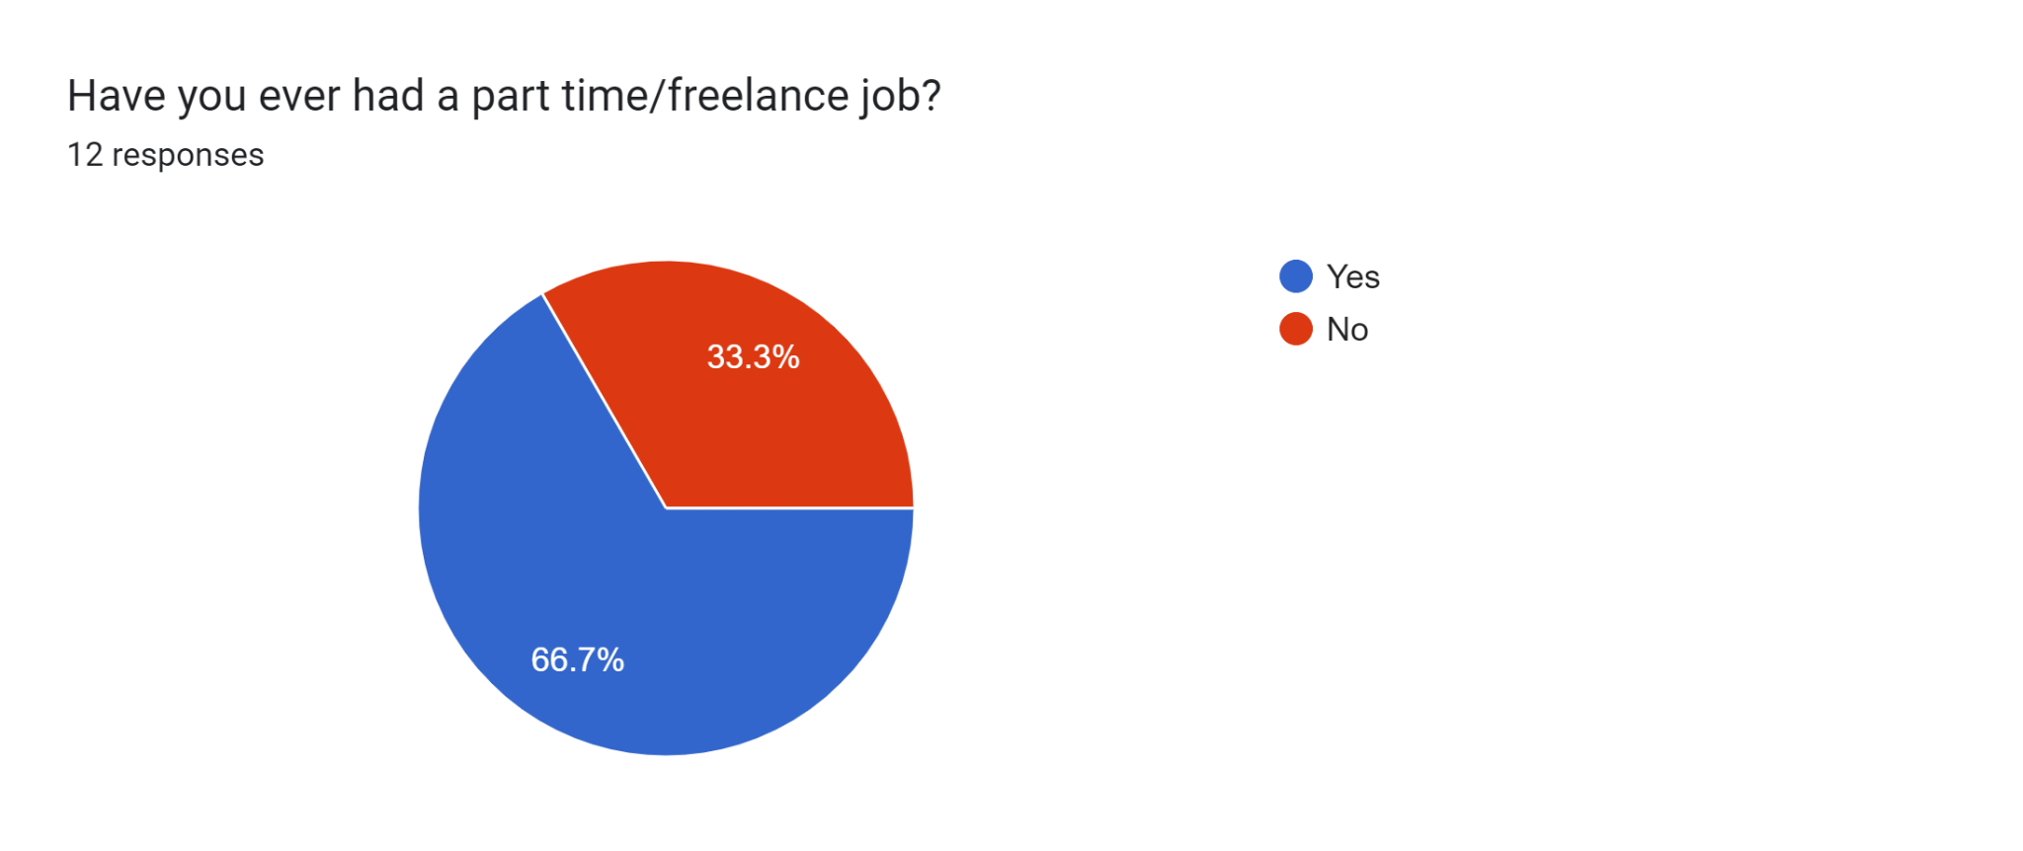

Figure 1.2.1

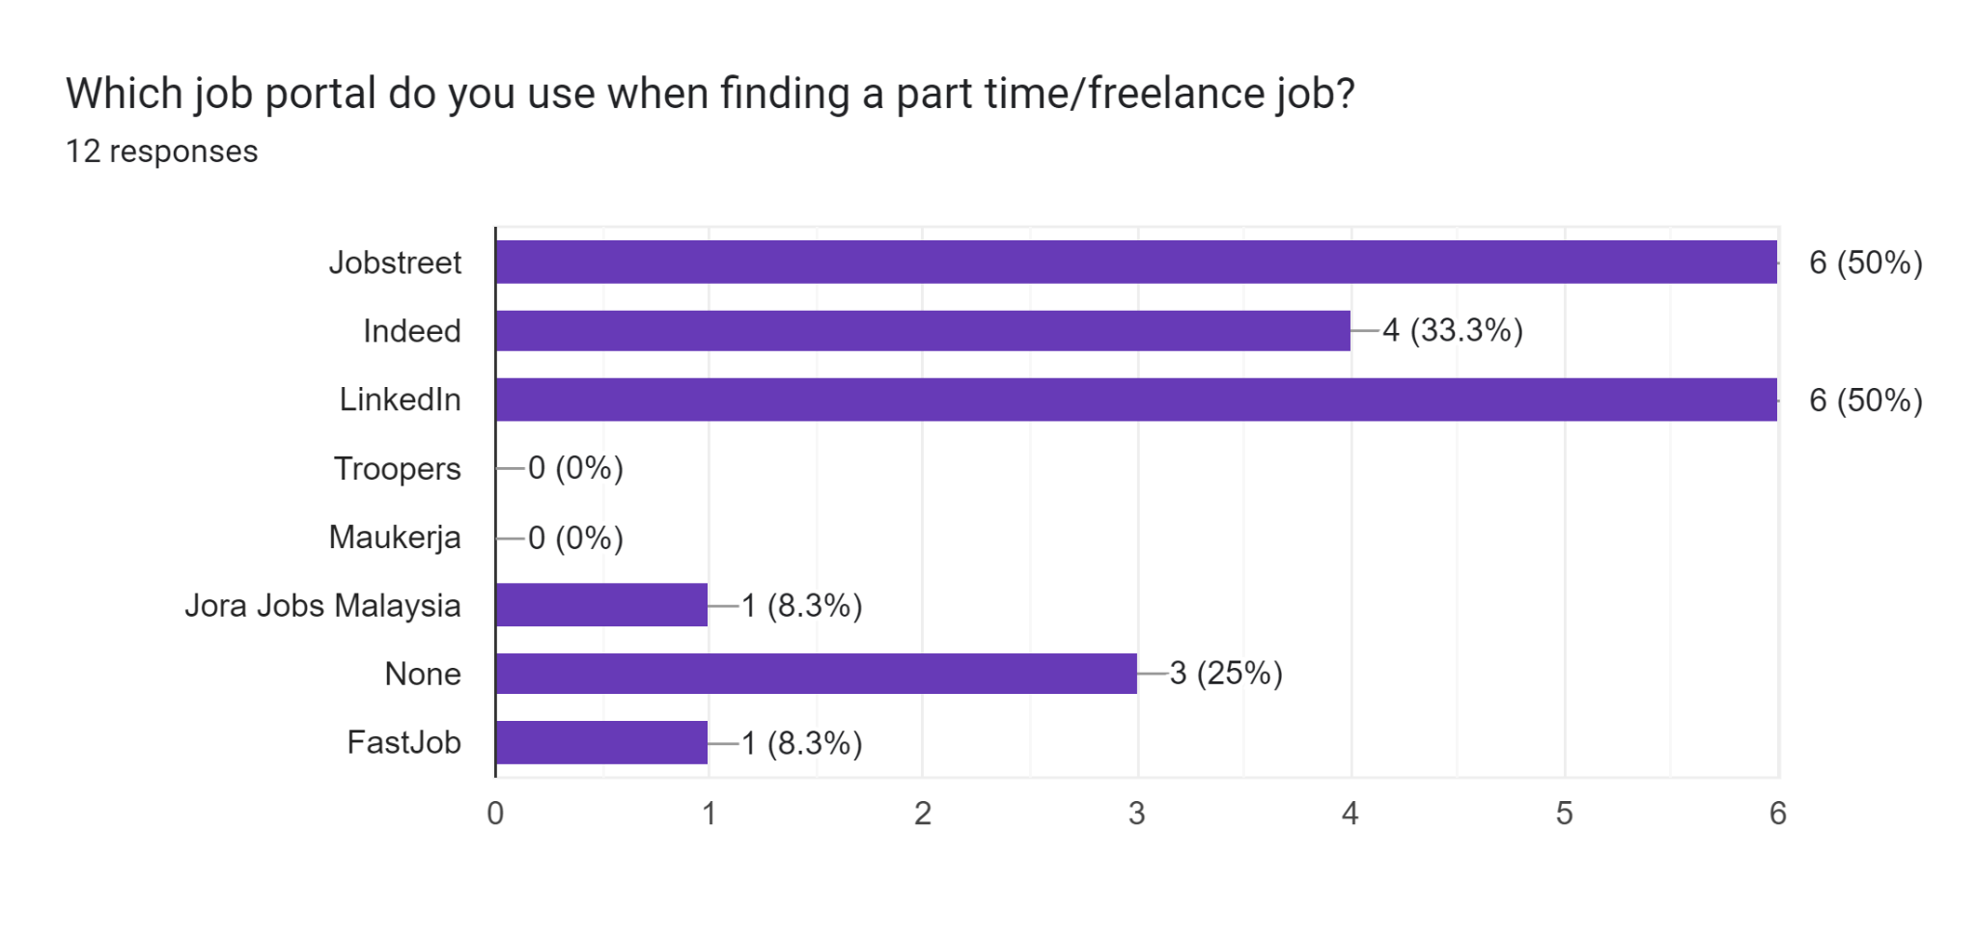Figure 1.2.2

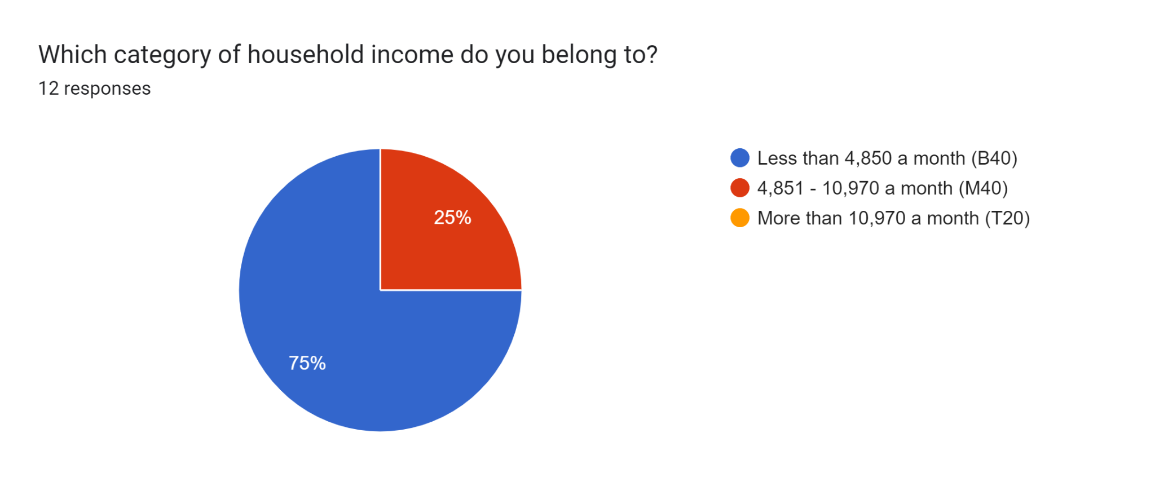

Figure 1.2.3

Customer Analysis

**Targeted customer**

**Demographic:** Both male and female, age of 15 and above, B40 and M40 citizens, Malaysian or foreigners working in Malaysia.

**Reasoning for gender:** According to the Department of Statistics Malaysia, there are 9.29 million and 5.92 million employed male and female respectively. While the amount of male labor force is significantly higher than the female labor force in Malaysia, the percentage of participation for employed male in the part time job market however does not differ by much with the female counterpart.

**Reasoning for age**: Part time employment by definition refers to citizens of age 15 and above (Employment of Children and Young Person, n.d.).

**Reasoning for income group**: Initially the application was designed to cater towards the B40 income group of Malaysians. The assumption was that the lower income group would be more likely to seek a part time job. However, a survey conducted on students of INTI and Politeknik Tun Syed Nasir Syed Ismail has shown that there is virtually no correlation between household income and the participation in part time employment.

**Reasoning for geographical restriction:** The application will initially cater only to people working in Malaysia with the most basic infrastructure. The possibility of expansion to other countries will not be excluded and will depend largely on the profitability as well as growth of the business.

Competitor Analysis

There are four main competitors to Grind, namely JobStreet, Indeed, Trooper and GoGetter. JobStreet and Indeed mainly caters to full time job seekers while Trooper and GoGetter focus exclusively on part time and freelance job seekers.

An essential point to note is that unlike other industries, the part time employment service market is not mutually exclusive. Users are not only limited to a particular application. This statement can be backed by the empirical data collected in Figure 1.2.2.

Despite two-thirds of the participants have had a part time job, none of the participants are actually using applications that cater specifically to part timers. This signifies that there still is not a particularly dominant player in this niche market, and the barrier for new entrants for now is low.

Main Competitors

**JobStreet**

JobStreet was founded in 1997 and is the biggest employment service application in Malaysia. JobStreet is very dominant in the full time employment market in Malaysia. Based on JobStreet’s annual report, the number of employers and job seekers have been steadily growing. However JobStreet still has some flaws for the part time market as most of the part time job postings in JobStreet are recruitment for insurance agents and property agents.

**Indeed**

Indeed was co-founded in 2004 in both Texas and Connecticut, U.S. By far, Indeed has the largest number of subscribers among all the competitors. However unlike JobStreet where the customers are mainly from Malaysia and Singapore, Indeed has an international presence throughout the world. Therefore, comparing such a huge corporation with local companies would be inappropriate.

**Troopers**

A relatively new part time employment company. Troopers focuses exclusively on the part time job market and has been doing quite well. In spite of that, Troopers lack the popularity that could take the company to a bigger stage.

**GoGetter**

Similar to Troopers, GoGetter focuses on the part time job market. However the amount of job postings for GoGetter are relatively less than Troopers.

Competitor’s Strength and Weaknesses Analysis

The table below is a summary of customer’s review in the Play Store. An analysis of the competitor’s weakness and strengths are conducted below.

| **Name of Company** | **Ratings and Subscribers** | **Strengths** | **Weaknesses** |
| --- | --- | --- | --- |
| JobStreet | Ratings: 4.6/ 5.0  Subscribers: More than 10 million | * Ease of use * Fast response time * Large variety of jobs listing * Verification of companies | * Content is cluttered * Outdated job postings |
| Indeed | Ratings: 4.7/ 5.0  Subscribers: More than 100 million | * Ease of use * Clear instructions for beginners * Fast response time | * Irrelevant job search results * Lack of a functional filter * Outdated job postings |
| Troopers | Ratings: 3.9/ 5.0  Subscribers: More than 100 thousand | * Payments are organized * User friendly * Clear instructions for beginners * Content is well organized | * Limited amount of jobs * Unjustified low ratings * Sudden job cancellation |
| GoGet and GoGetter | GoGet  Ratings: 3.2/ 5.0  Subscribers: More than 100 thousand  GoGetter  Ratings: 3.8/ 5.0  Subscribers: More than 100 thousand | GoGet   * Good user interface * High quality labor * Reliable * Fast response time   GoGetter   * Flexibility * Fast response time * User friendly * Innovative way for part timers to earn a token | GoGet   * Requests are constantly declined by the employees * Unable to navigate through the application due to system failure   GoGetter   * Limited amount of jobs * Bad user experience * Login error |

Table 1.0: Customer’s Review in the Play Store

Personal Findings and Market Survey

The table below is a summary of personal experience in the various applications stated below.

| **Name of Company** | **Experiences** | **Strengths** | **Weaknesses** |
| --- | --- | --- | --- |
| JobStreet | * An employee of JobStreet will ask for documents to verify the existence of the company. The fake account that has been created for the purpose of this assignment has been disabled. * Despite inputting “part time” in the search bar, several full time job postings have appeared in the search result * Employers have tried to set up an interview after just a day of requesting for the job | * Employer verification * Categorization of jobs based on specializations * A huge variety of job postings * Fast response time * Relatively easy process of submitting an application | * A few irrelevant search results * Outdated job postings which has been in the application for more than 20 days * Few part time vacancy postings with the majority of the postings being insurance or property agents |
| Indeed | * Unable to accept a Malaysian phone number when attempting to advertise a job posting | * Relatively easy process of submitting an application * Huge variety of part time postings | * Outdated job postings which has been in the application for more than 20 days |
| Troopers | * Employer verification has to be done before any part time job vacancies can be advertised * Only way of contacting Troopers is through email as the phone number stated is unavailable | * Important info can be viewed at a glance * Verification of companies | * Limited amount of job postings * Does not classify job postings * Difficult to reach |
| GoGet and GoGetter | GoGet   * Relatively easy experience when creating job postings   GoGetter   * Instructions in the form of video has been given so that employees will know the modus operandi of the company * No available job postings to apply * Application has slow response time | GoGet   * Great user experience * User friendly   GoGetter   * Clear instructions for beginners | GoGet   * Limited variety of job postings that can be advertised   GoGetter   * Zero job postings available * The application has a slow response time when initiating a new action |

Partners (Suppliers) Analysis

The partners for Grind will range from big Multinational Companies such as Uniqlo and Bata, to small scale businesses. Challenges may arise from attempting to partner up with small scale businesses. This is due to most of the small scale businesses may not see the value and find it unnecessary to incur additional cost in recruitment.

Political Climate Analysis

**Increase in Minimum Wage**

Since May 2022, the government has gazetted a minimum wage of RM1,500 per month which translates to RM7.21 per hour.(Azreen Azmi, 2022). This is a huge increase from the RM900 minimum salary. Such a policy would increase the cost for employers which in turn gives the employer incentives to decrease the number of hiring.

**Laborers Union and Strike**

Unlike the western countries, the laborers union in Malaysia is a relatively docile one. Protests and strikes rarely happen and this is likely to persist in the foreseeable future.

**Sales and Marketing**

**Pricing Model**

Pricing model represents the way a software company generates revenue. The pricing model relevant to the online employment company is as follows:

Subscription

Subscription allows the user to enjoy the service by paying a fixed amount of premium for a recurring period. This pricing model allows the user to cancel the subscription at any time should the user feel that the service is no longer necessary. One of the advantages of the subscription model is that there will be a greater customer retention rate due to guaranteed return spenders (GoCardless, 2022). Subscription-based business model also provides the company with a steady and relatively predictable income (GoCardless, 2022). However, this model runs a risk of losing existing customers if the service is deemed outdated.

Freemium

Freemium refers to one of the pricing models that are more widely used in an application software. The services implementing this pricing model are usually offered in both free and paid versions. The strategy behind freemium is to allow users to be engaged with the product free of charge and then charge the users when additional features or services are requested. The main advantage of freemium is getting new users quickly (Solomon, 2022). However freemium poses a challenge in which the development team should strike a balance between giving the customers too many or too little functions. The former may cause the customer to no longer have the need to upgrade while the latter may cause a negative user experience.

Commission Fee

Commission fee will only incur if a particular transaction is successful. There are two types of commission fee pricing model, namely one based on percentage and another based on minimum fee (Vidal, 2019). The advantage of the commission fee model is that new customers will be less intimidated by the pricing as compared to having to pay a hefty premium before anything is accomplished at all. Nevertheless, the commission fee pricing model relies heavily on the success of customers and this may lead to a slower revenue generation.

In-app Advertising

In-app advertising is another way a business can generate revenue. This model helps other businesses to advertise featured products or services in return for an advertising fee. Applications that are free of charge usually adopt this pricing model. The advantage of this model is that the user base can grow quickly as people tend to have little to no resistance for products or services that are free of charge. However, unskippable in-app advertising will usually annoy and adversely affect user experience.

Competitor’s Pricing

| **Name of Company** | **Main Target Market** | **Pricing Model** | **Comments** |
| --- | --- | --- | --- |
| JobStreet | Full time | * Monthly subscription | * The pricing is charged on the employer’s side. * Amount of premium will be based on the features of the package * Employee job seeking is free of charge |
| Indeed | Full time | * Freemium | * Employer job posting is free of charge, however additional features and benefits requires a premium * Employee job seeking is free of charge |
| Troopers | Part time | * Commission Fee | * Employers will be charged by a percentage of service fees after a successful recruitment * Percentage differs based on the quality of labor * Employee job seeking is free of charge |
| GoGet & GoGetter | Part time | * Freemium * In-app advertising * Commission Fee | * Employer job posting is free of charge, however if however additional features and benefits requires a premium * Employee is charged a commission on every job taken |

Grind’s Pricing Strategy

Since the application mainly serves the part time job market, a monthly subscription method of revenue does not seem to be appropriate. Most small scale businesses do not have the need to advertise vacancies on a monthly basis. Another model that should be avoided is the in-app advertising. Unlike recreational applications such as mobile games, productivity is the main concern for Grind. In-app advertising will only cause a distraction to the user’s job finding experience and no amount of revenue can be justified to compromise the user experience.

Similar to Troopers and GoGetter, Grind will be adopting the commission fee strategy as its main source of revenue. However the commission will be levied on both the employer and potential employees for the service granted to them. 10% of service fee will be imposed on both parties and this represents the only package that Grind is currently offering. Service fee will only be incurred when a matching between the employer and potential employee is successful. The rationale behind such a pricing strategy is inline with one of the company’s values, which is to treat all the stakeholders in a fair manner.

**Marketing Strategy**

Online Search Advertising

Online search advertising refers to advertisements that are placed in the search engine results. This form of advertising is also commonly known as “pay-per-click” advertising. An example of online search advertising is Google’s Adwords. The way Google’s Adwords operate is similar to an auction system ("Search Advertising: Learn How to Advertise on Search Engines", n.d.). The highest bidder is able to secure the location as well as when the advertisement will appear. Careful selection of targeted audiences and the optimal time for advertising may save the business from a lot of costs.

Physical Advertising

Physical advertising refers to advertisements that are done in the real world (Shafer, E., n.d.). This includes advertisements on the posters, banners and even highway billboards. There is usually a tradeoff between the cost of advertisement and the optimal location for advertising. Based on the research of a local advertising company, the cost may range from RM9,250 a year to RM150,000 a year. Physical advertising is an effective way to reach the local audiences by displaying at locations with high flow of traffic. Unlike other forms of advertising, physical advertising usually requires a lump sum payment at the start. For instance, advertising in static billboards will require the business to sign a contract that specifies how much money is to be paid for a predetermined amount of time. This form of advertising is not recommended for new businesses.

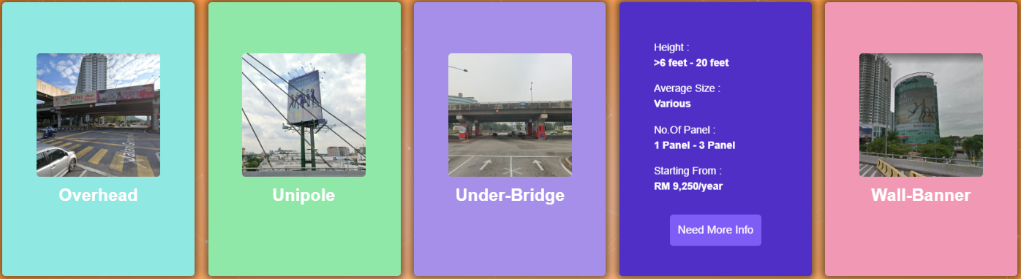

Figure 2.1 A catalog of billboards taken from a local advertising company

Social Influencer Advertising

Social influencer advertising refers to a mutualistic relationship between a company and a social influencer. This method of advertising is not the same as getting an endorsement from a celebrity (Matthew, J., 2018). While celebrity endorsement does nothing more than attaching the brand to a celebrity’s name, influencer marketing requires the influencer to be knowledgeable or relevant to the product or service a business is promoting. Businesses should also be aware of influencers who boost up the numbers with fake followers. This type of marketing has a greater chance of allowing the product or services to reach an audience that meets the interest or demographic of the targeted customer.

Referral advertising

Referral marketing refers to the strategy of making use of the recommendations given by customers to grow a business’s customer base (Patel, S. 2021). Referral marketing is usually effective as potential customers are more receptive to the views given by peers, family or friends. Incentives are usually given to existing customers that have provided a successful lead. Not only will this retain the customer’s loyalty, it is also a way of bringing in the users. While referral marketing is relatively cheaper than other forms of marketing, the downside is that the results may be slow.

Grand’s Marketing Strategy

Grind will be implementing 3 different types of marketing strategies. Grind’s more active way of marketing will be through social media and online search advertisements such as Facebook and Google. The reason why Facebook was chosen instead of Instagram despite the latter’s popularity with the younger audience is because Instagram lacks the infrastructure to create groups and publish posts to strangers. Whereas Facebook is predominantly the optimal choice for social media marketing. Besides that, Grind will also be running Google ads consistently. The justification is that job seekers will usually seek out for jobs in Google if they do not already have a job-seeking application.

The second type of marketing strategy is through referral fees. This represents a more passive approach to marketing. This strategy has been used by many of the applications stated above. Referrers and referees will be rewarded with a one-off RM10 credit to their account once a new user has successfully created his account. By implementing such a strategy, not only will this retain existing customers’ loyalty, it may also pull in new users.

The third type of marketing strategy is more of a short-term campaign due to its relatively more costly nature. Grind will be advertising on Youtube as a way to publicize the application’s existence. Ideally, the campaign will run for the first three months after the application is launched. The campaign will also be relaunched during long term school holidays.

Grind’s targeted audience for marketing campaign

Both male and female, age of 15 and above, B40 and M40 citizens, Malaysian or foreigners working in Malaysia, algorithms register interest in job finding.

Grind’s Estimated Cost of Marketing

Referral fees: RM10 (one-off payment)

Google ads: RM420(monthly)

Facebook ads: RM15.90 (daily)

Youtube ads: RM0.04 per view

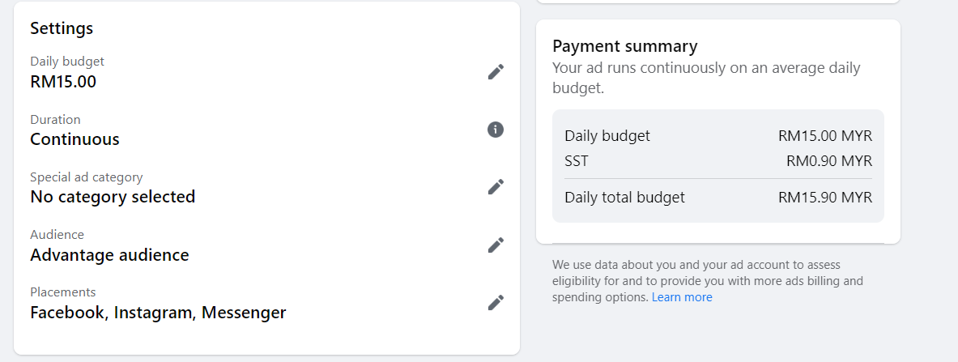

Figure 2.2 Facebook Marketing Cost

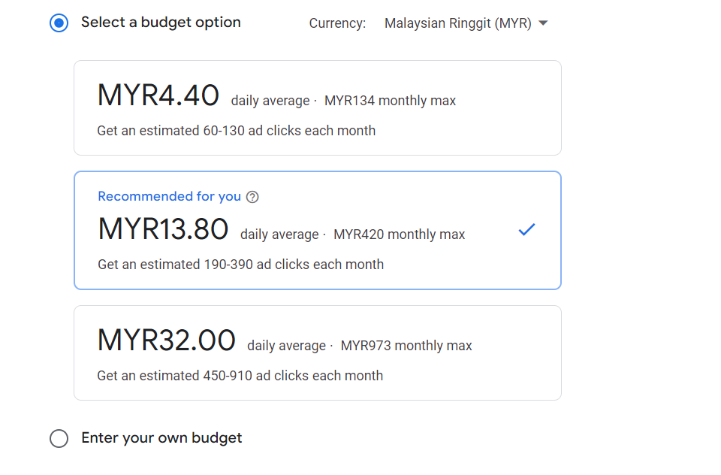

Figure 2.3 Google Adwords Marketing Cost

**Platform Analysis**

**Empirical Observation**

There is an even distribution between students who are using iPhones and Android phones. Hence, a conclusive decision cannot be made by pure observation.

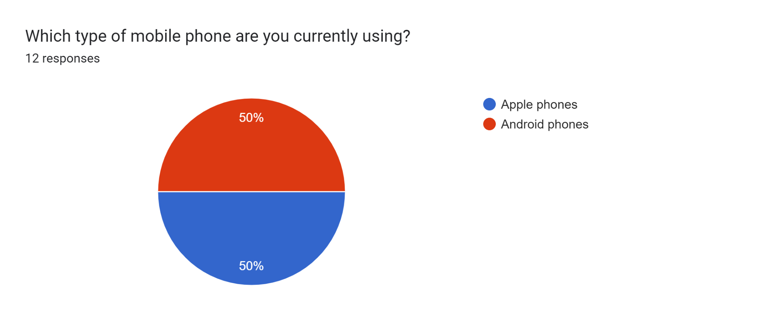

Figure 4.1

**Price comparison between Apple devices and Android devices**

iPhone

According to Financial Times, the average selling price of an iPhone is $944 in the fourth quarter of 2022 (Hong, P., 2022) . This translates to approximately RM4,187 in Malaysia. The average price of an iPhone has only been increasing every year. In 2021, the average selling price for iPhone is $950 or around RM4,213(Hamblen, M., 2021).

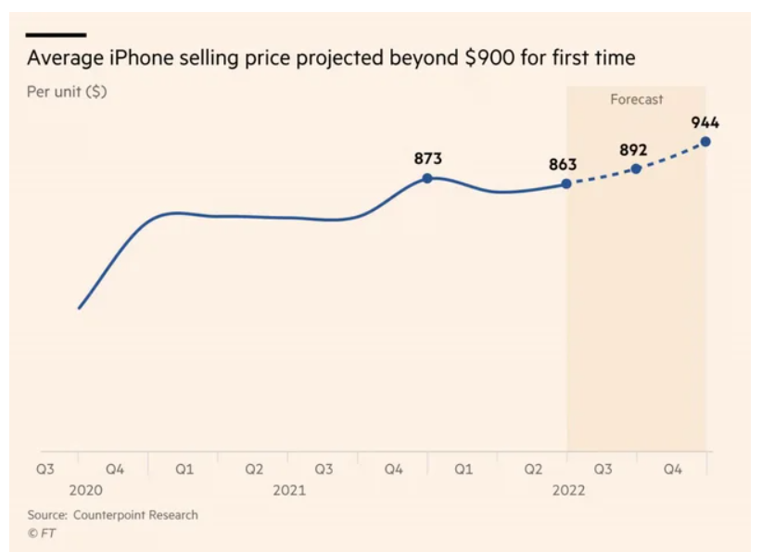

Figure 4.2 iPhone average selling price

Android Device

According to the IDC Worldwide Mobile Phone Tracker, the average selling price of an Android device has always been lower than the iOS counterpart. Lately, the gap between the prices has started to grow.

In 2021, the average selling price of an Android device is $250 or RM1109 (Hamblen, M., 2021).

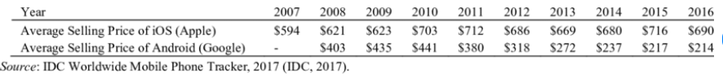

Figure 4.3 Average Selling Price for Android and iOS devices

Decision Based on Pricing

Since the data on Android’s average selling price can only be obtained up to 2021, comparison between the price of iOS device and Android will be made as an approximation. In 2021, the average price of iOS is almost four times the price of the Android counterpart. As the application is mainly catered to B40 and M40 Malaysians, developing an application on a cheaper platform is preferable than a more expensive one.

**Market Share in Malaysia**

As of January 2023, iOS made up 28.89% of mobile operating system market share in Malaysia. This represents almost a quarter of the total market share. While Android made up 69.65% of market share in Malaysia. The market share of Android is more than twice the amount of iOS. Other operating systems made up less than 2% of the total market share, and hence can be omitted.

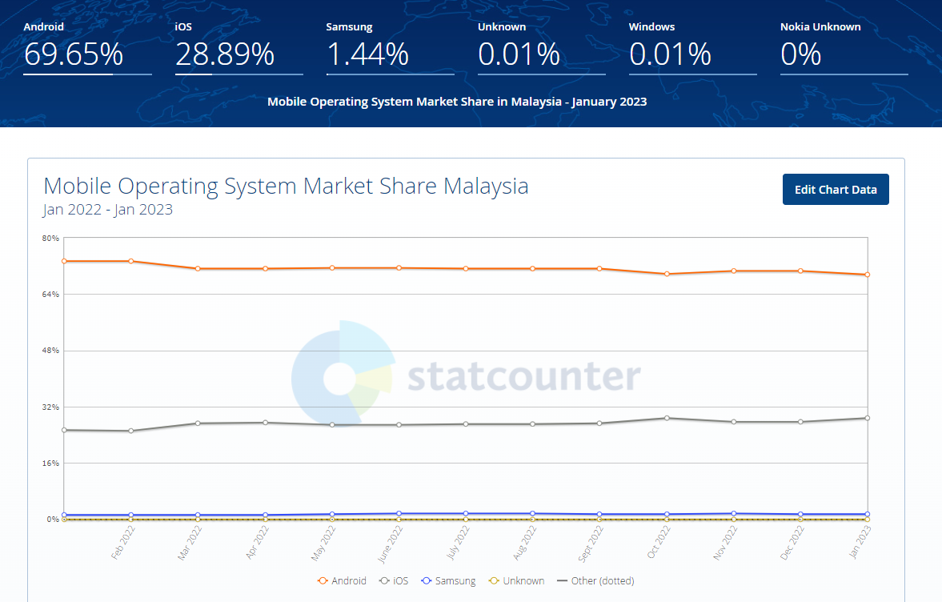

Diagram 4.4 Market Share of Mobile Operating System in Malaysia

Decision Based on Market Share

A larger market share signifies an opportunity to reach out to more potential customers. Unlike premium products and services such as Rolex or Lamborghini, Grind relies heavily on the number of users as the services provided are catered to the masses rather than exclusively to the rich. Therefore, Android shall be chosen as the platform due to the greater number of users.

**Cost Comparison**

Apple Store

A yearly subscription of $99 or RM439 will be imposed by Apple to develop an application on the platform (Deed, I., 2023). For the first year, Apple charges a whopping 30% commission on all in-app purchases as well as subscription. If the company earns less than 1 million USD in revenue after deducting Apple’s commission and other adjustments such as tax, the company is eligible to apply for the Small Business Program to reduce the commission to 15%. Otherwise, the commission rate will remain the same. It should be noted that the commission rate does not apply to applications that are free of charge.

Google Play Store

A one-time payment of $25 or RM111 will be imposed by Google Play Store to develop an application on the platform (Girdhar, A., 2022). Should the developer decide to upload new applications onto the platform, the fee will not be imposed anymore. According to the Help Center from Google, the service fee is charged based on tier. 15% of service fee will be levied on the first 1 million USD revenue earned by the developer. Any amount exceeding the first million will be charged 30%.

Decision Based on Price

|  | Apple Store | Google Play Store |
| --- | --- | --- |
| Developer License Fee | RM439/ year | RM111 (one-off) |
| Commission Fee Rate | 1. Year 1: 15% 2. Subsequent year:  * 15% if revenue is less than RM4,435,500 * 30% if revenue is more than RM4,435,500 | 1. 15% for the first RM4,435,500 revenue 2. 30% for every amount exceeding the RM4,435,500 revenue |
| Scenario 1 (Revenue RM3,000,000 for 5 years) | Commission:   * Year 1: RM450,000 * Year 2: RM450,000 * Year 3: RM450,000 * Year 4: RM450,000 * Year 5: RM450,000     Total: RM2,250,000 | Commission:   * Year 1: RM450,000 * Year 2: RM450,000 * Year 3: RM450,000 * Year 4: RM450,000 * Year 5: RM450,000   Total: RM2,250,000 |
| Scenario 2 (Revenue RM5,000,000 for 5 years) | Commission:   * Year 1: RM750,000 * Year 2: RM1,500,000 * Year 3: RM1,500,000 * Year 4: RM1,500,000 * Year 5: RM1,500,000   Total: RM6,750,000 | Tier 1: RM665,325  Tier 2: RM169,350  Commission:   * Year 1: RM834,675 * Year 2: RM834,675 * Year 3: RM834,675 * Year 4: RM834,675 * Year 5: RM834,675   Total: RM4,173,375 |
| Scenario 2 (Revenue RM10,000,000 for Year 1 and RM3,000,000 for subsequent years) | Commission:   * Year 1: RM1,500,000 * Year 2: RM450,000 * Year 3: RM450,000 * Year 4: RM450,000 * Year 5: RM450,000   Total: RM3,300,000 | Tier 1: RM665,325  Tier 2: RM1,669,350  Commission:   * Year 1: RM2,334,675 * Year 2: RM450,000 * Year 3: RM450,000 * Year 4: RM450,000 * Year 5: RM450,000   Total: RM4,134,675 |

The developer license fee imposed by Apple is a lot more expensive than the Play Store counterpart.

Not only is the fee relatively higher than the Play Store, the fee is also a recurring expense for the developer every year. Based on the scenarios above, the commission fee of Play Store seems to be the same if not cheaper than Apple in almost every scenario. The only possibility where the commission levied by Apple may be cheaper than Play Store is when scenario 3 occurs, which is highly unlikely. Therefore, Play Store is chosen as the cheaper alternative.

Comparisons of Other Aspects between Platforms

|  | Apple Store | Google Play Store |
| --- | --- | --- |
| **Flexibility** | Low (Closed Source)  Apple Store can only be run on devices made by Apple ("Advantages and Disadvantages of iOS", 2021)  . | High (Open Source)  Google Play Store can be run on virtually every device except for devices made by Apple. |
| **Customer Loyalty** | Lower  According to a report written by Consumer Intelligence Research Partners in 2018, Apple has 86% customer retention rate. | Higher  According to a report written by Consumer Intelligence Research Partners in 2018, Android devices have a 91% customer retention rate. |
| **Customer Demographic** | Relatively Higher Income  A survey conducted in 2018 has found that the average annual income for iPhone users is $53,231 (Szczygiel, B., 2022). | Relatively Lower Income  A survey conducted in 2018 has found that the average annual income for iPhone users is $37,040 (Szczygiel, B., 2022). |
| **Developer Support** | Relatively Less Developer Support  Since Apple is a closed source operating system. The tools and codes available for developers are relatively less than what Google Play Store can offer. | Relatively Greater Developer Support  Google Play Store is an open source operating system. Greater developer support signifies developers have a relatively easier time to create applications by using the wide range of free tools and code available (McDonald, T., 2021). |

**Final Decision**

When it comes to platform selection, there are two important factors in making the decision. The two factors are the cost and the market share. This is because the factors actually affect the bottom line of the company. Google Play Store is relatively better than the Apple Store in these two areas. Besides that, there are also several aspects where Google Play Store is relatively better than Apple Store. Therefore, Google Play Store will be selected as the platform to develop at.

**Design**

**Principles implemented in the designing of Grind**

Keep it simple

The main designing principle of Grind is simplicity. A complex design makes it harder to communicate the application’s value to its users (Lawrence, N. 2020). As a rule of thumb, the application should be designed in such a way that users of any age group without technological background are able to access the application easily.

Safe exploration

The design should be forgiving, in which the users are able to explore the user interface without any repercussions (Tidwell, J 2011). For instance, Grind has a “Back” button that allows users to go back to the previous page.

Less is more

Grind adopts a minimalistic approach by removing elements that are not material in the job finding process. According to Tidwell, J. (2011), if the user can achieve the main objective without having to use a particular function, the function should be gotten rid of altogether.

If it isn’t broken, don’t change it

Grind’s UI is built on top of an existing design. A complicated interface often lays a large cognitive cost on newcomers (Tidwell, J 2011). An unnecessary redesign of the user interface would steer most newcomers off as users are unlikely to leave their comfort zone.

**Tools implemented in the designing of Grind**

White Space

An important but often overlooked element of UI/UX design is the white space. White space refers to the area between design elements (Soegaard, M. 2021). The purpose of white space is to organize the contents in a more visually appealing way. This allows the user to have an increased attention as well as a higher comprehension when using the application (Boag, P. 2011). To sum it up, white space provides an elegant and immersive user experience.

**Grind Pages**

Login Page

The login page will ask the user for the credentials in order to gain access into the account. The Login page also has the “Sign Up” button that allows new users to register a new account. The “forgot password” will help existing users to retrieve forgotten passwords by sending an OTP to the phone number.

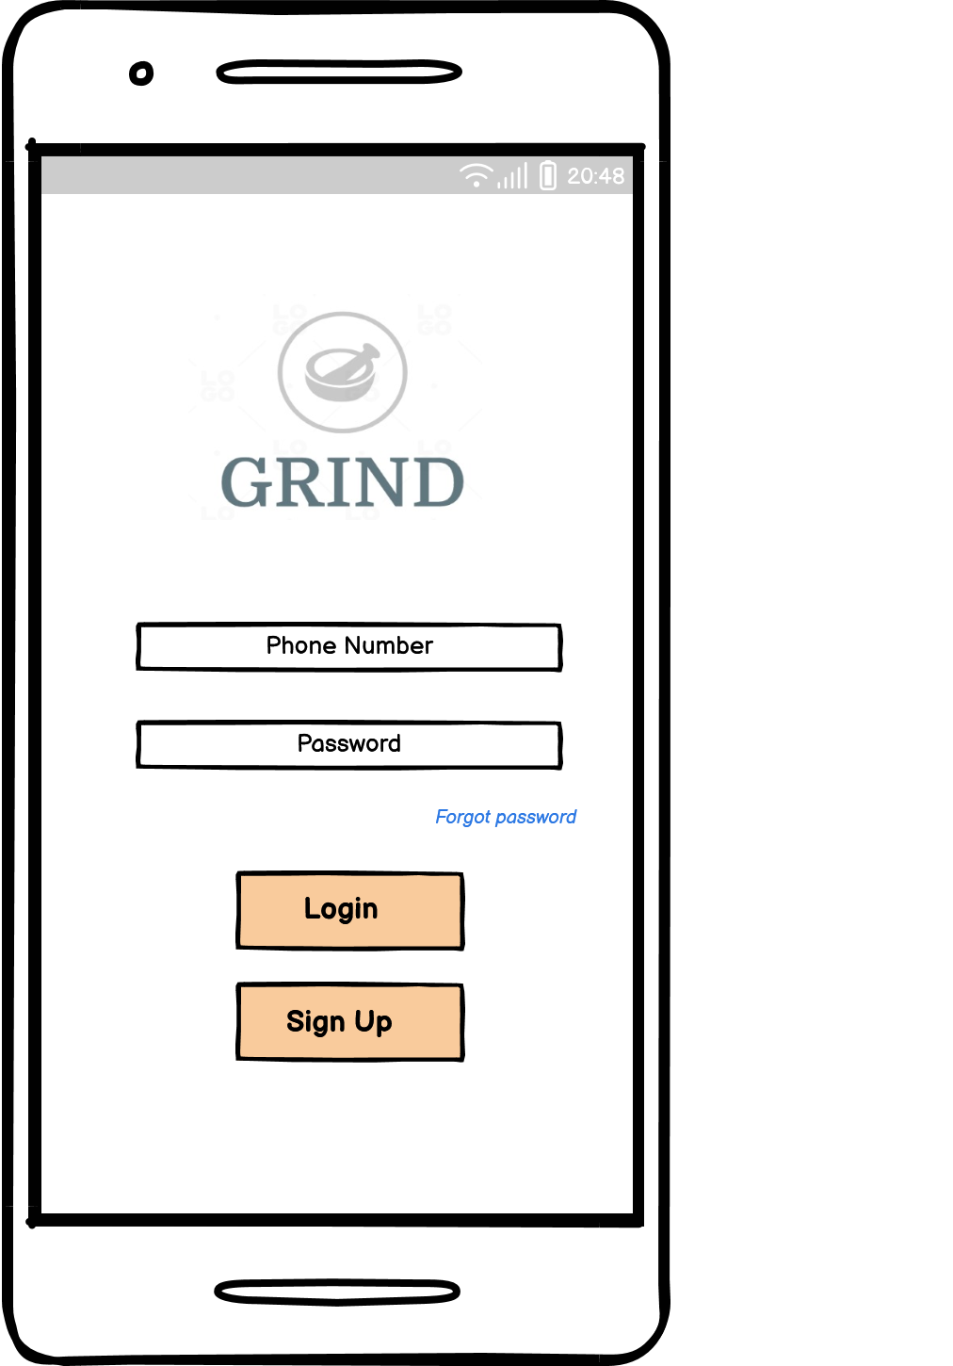

Figure 4.1 Login Page

Sign Up Page

The sign up page allows new users to register a new account. This page prompts users for several credentials such as name, phone number and password. The password input should be at least 6 characters long to be considered acceptable. An optional referral code field will be provided if the new user was introduced to the application by someone else.

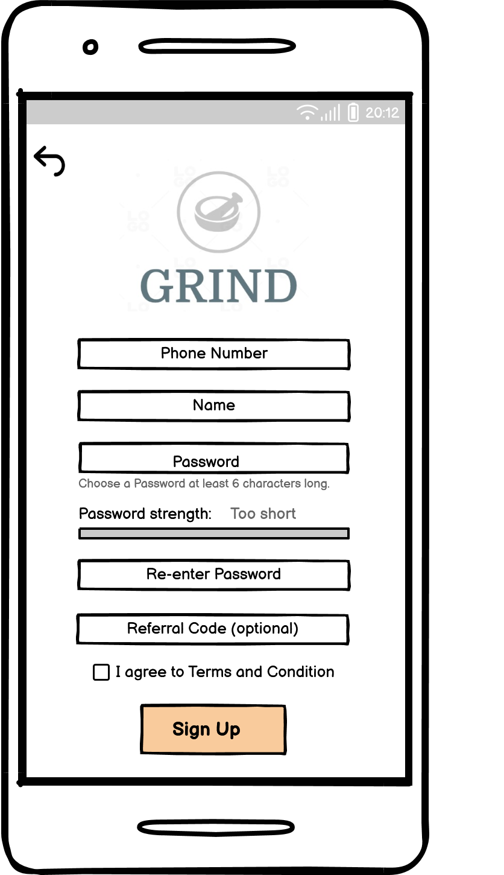

Figure 4.2 Sign Up Page

OTP Page

Since the application will be handling sensitive data and cash transactions, an OTP is required for security purposes. An OTP will be sent to the user’s phone after the user has clicked onto the “Sign Up” button in the sign up page. There is an option to resend the OTP should the user not receive the OTP.

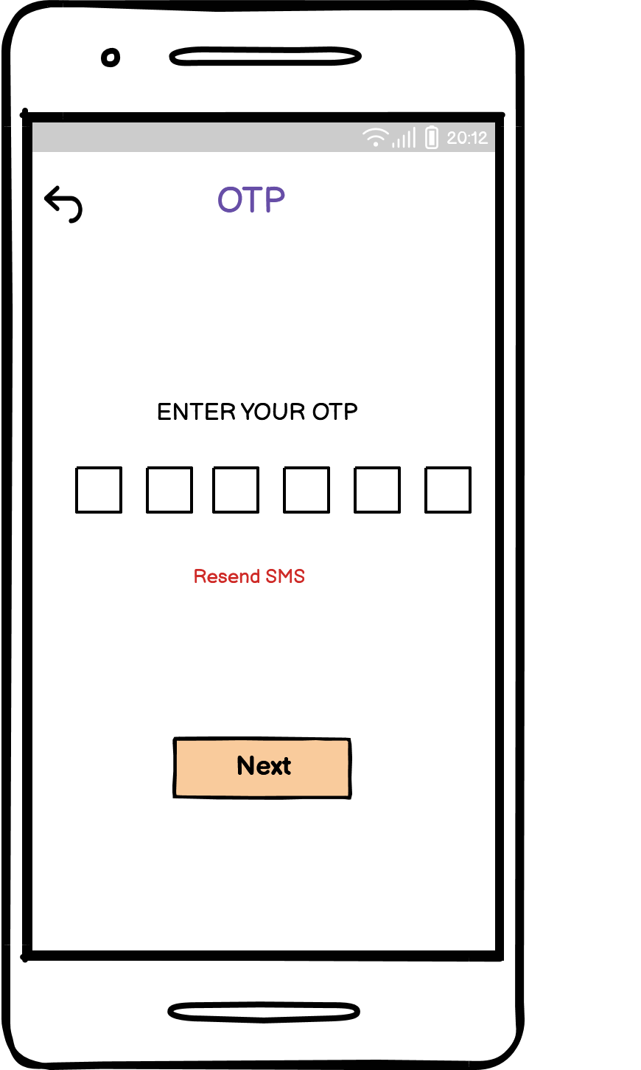

Figure 4.3 OTP Page

IC Upload Page

This page will require the user to upload the front and back image of the identification card. This requirement is necessary for verification purposes.

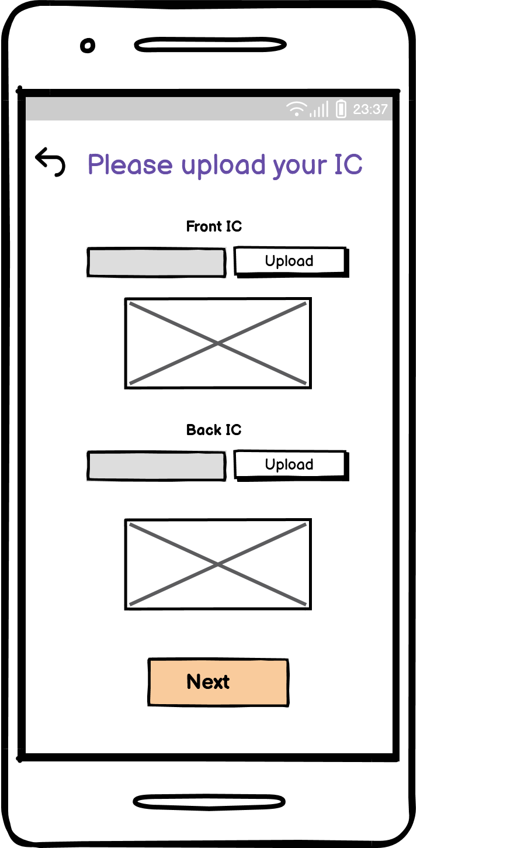

Figure 4.4 IC Upload Page

Verification Page

After uploading the identification certificate, the user will have to wait for the Grind’s staff to do a verification. As the verification process may take some time, the progress bar is there to reassure the user that the application is currently being processed.

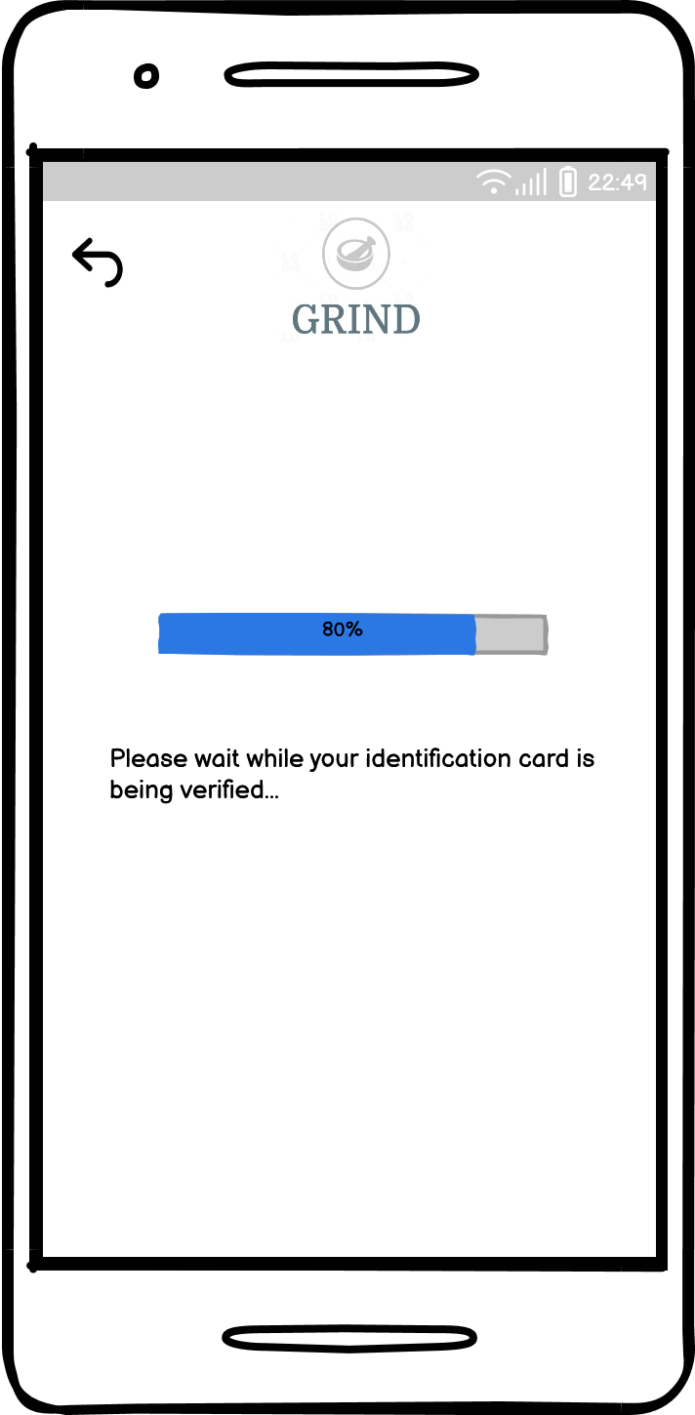

Figure 4.5 OTP Page

Edit Profile Page

Once the identification certificate is deemed acceptable, the user will be redirected to the edit profile page. This page allows the user to fill up personal information as well as to upload a resume. It should be noted that the “Edit Profile” within the settings menu (Figure 4.13.2) will redirect the user to this page too.

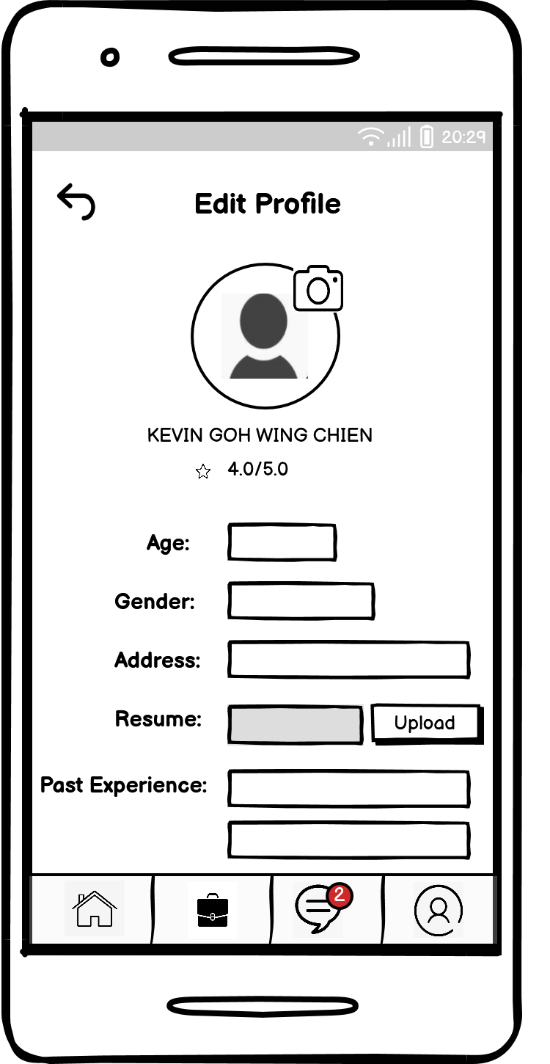

Figure 4.6 Edit Profile Page

Home Page

There are three components that make up the home page for Grind. Starting from the top is the “jobs feed”, where new jobs posted that aligns with the user’s preference will be visible. For the next part, the user is able to search for jobs either through keywords, through categories or through location. The final component for the home page is the announcement. This is where Important news and events are published.

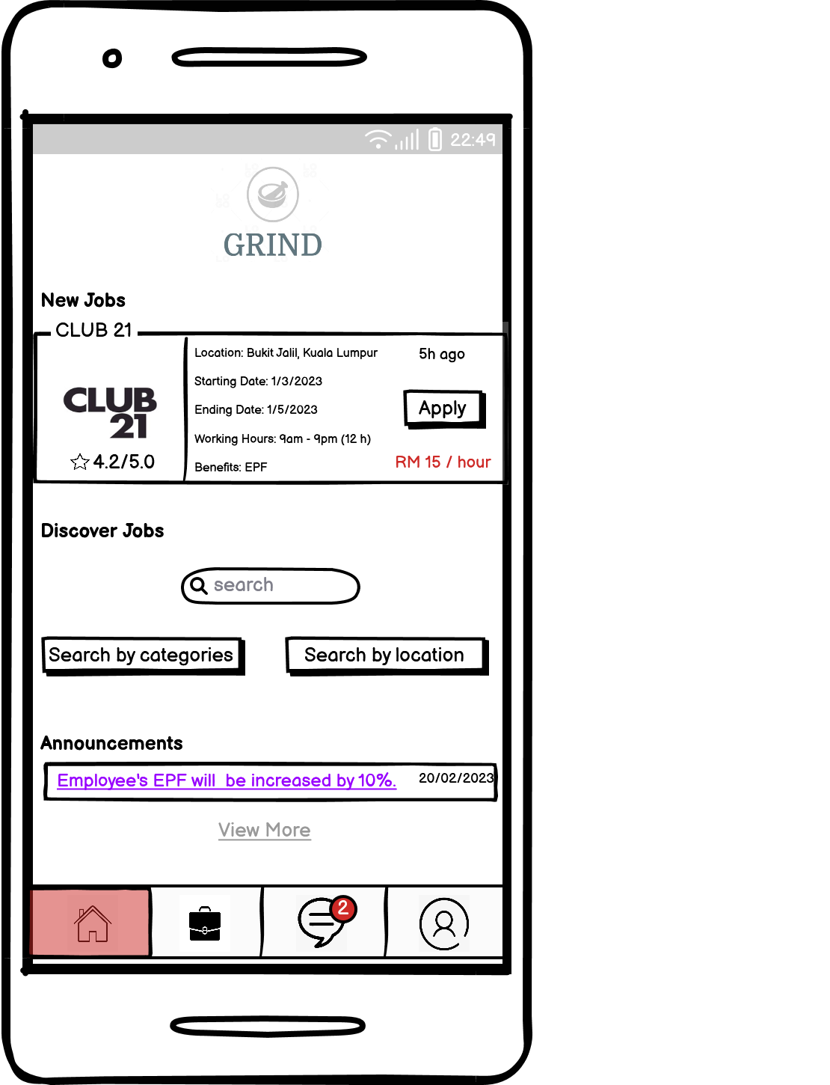

Figure 4.7 Home Page

Job Categories Page

This page is where users are able to find part-time jobs available by categories. The search bar provides an alternative to the user should the users already have a position in mind.

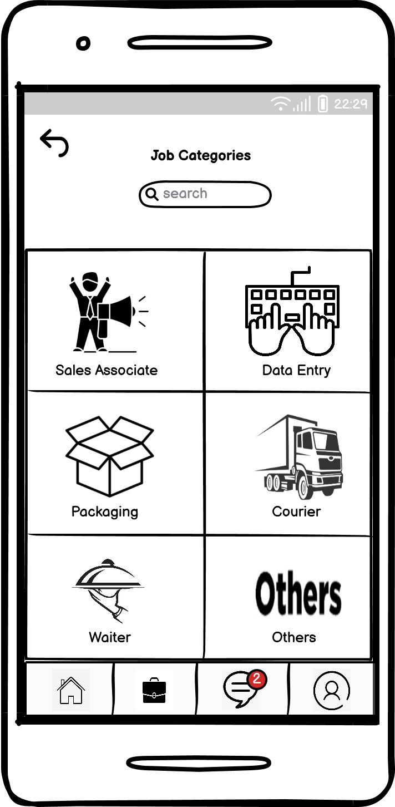

Figure 4.8 Job Categories Page

Job Specialization Posting Page

This page shows the available vacancy for the particular job. For instance, the figure below refers to the vacancies currently available for sales associates. Users will be redirected to the job information page if the “Apply” button is clicked. This page also allows the user to sort the vacancies available by amount of wages, date of the job postings and company ratings.

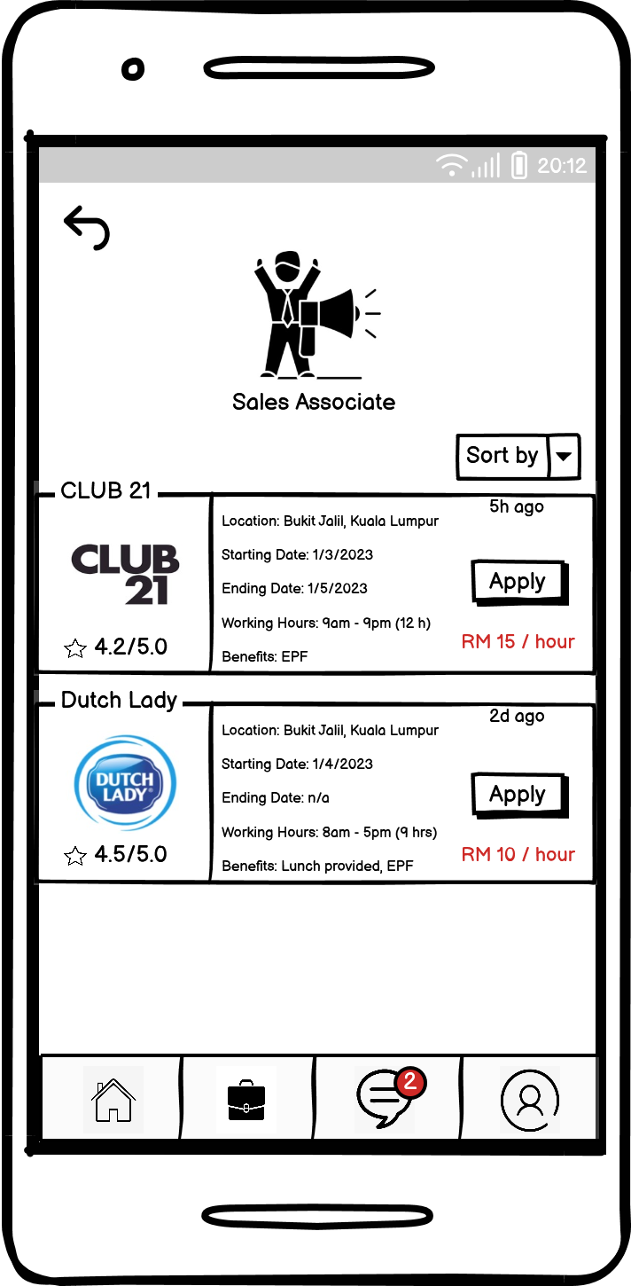

Figure 4.9 Job Specialization Posting Page

Job Information Page

Job information page provides more details on the particular vacancy. If the users are interested in taking on the job, clicking onto the “Apply” button will automatically send a request and the user’s information to the employer.

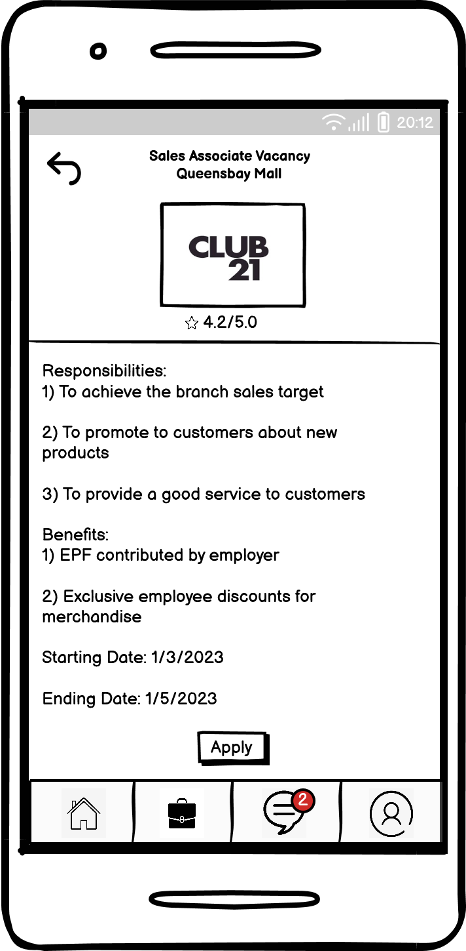

Figure 4.10 Job Information Page

Employer’s Profile Page

This page displays the employer’s background to the user. The page contains the ratings and important information about the employer. Available vacancies are also shown below at the page.

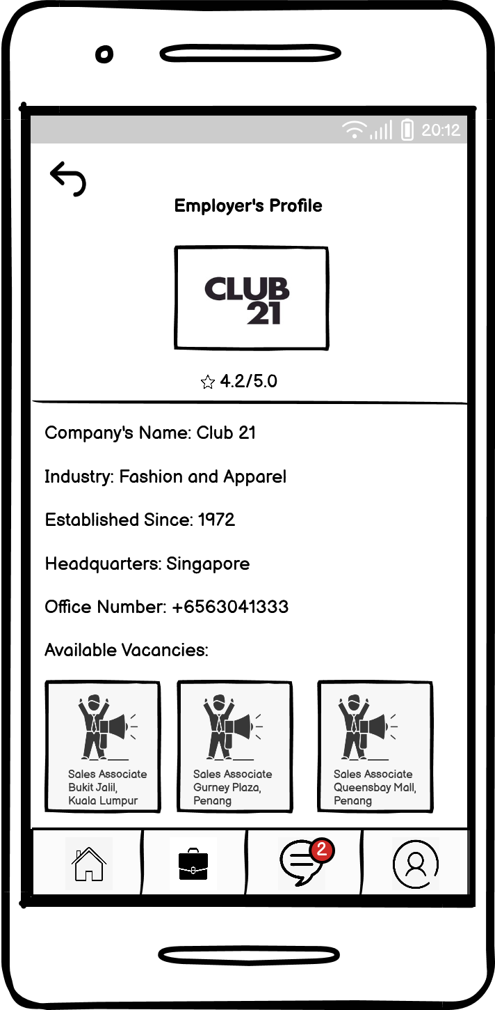

Figure 4.11 Employer’s Profile Page

Geographical View Page

This page allows users to search for part-time jobs nearest to the user’s location. The red dots represent the available vacancies for the particular state.

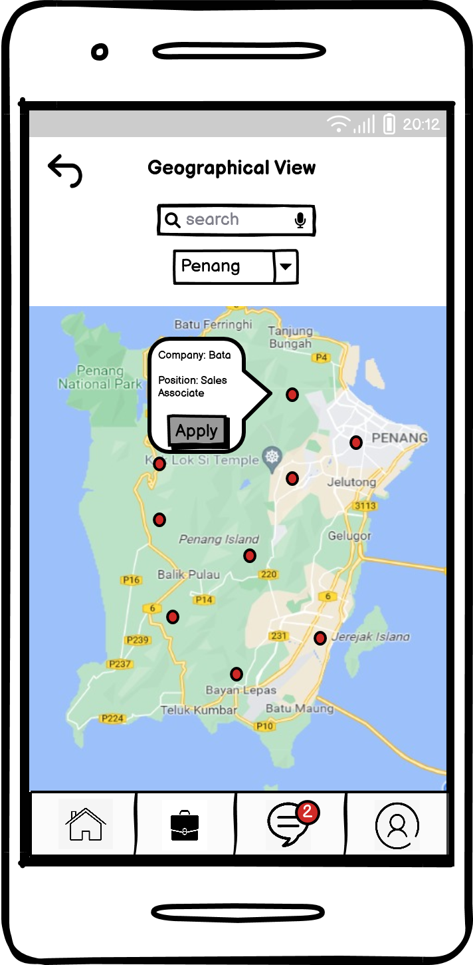

Figure 4.12 Geographical View Page

My Jobs Page

This page shows the user the status of all the jobs that the user has applied for. Accordion has been used to fit as much information as possible in the page. All the jobs applied by the user will first be placed within the third accordion (pending acceptance). Users at this stage are able to withdraw the job application. Once the user has been accepted by the employer, the table containing the employer’s info and the position applied will then be moved to the second accordion. The user has the right to accept or reject the employer’s offer. Upon the user’s acceptance of the employer’s offer, the users may also cancel the job request. However a reasonable explanation is expected from the user.

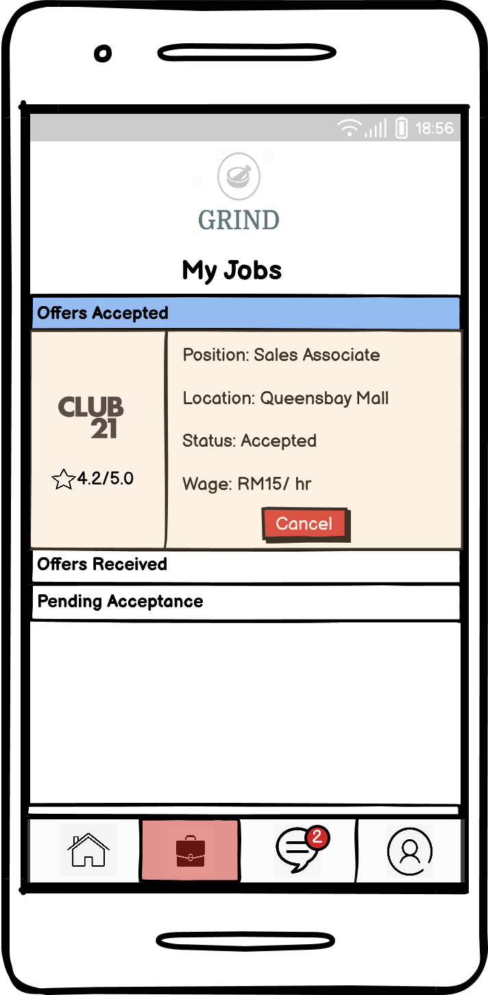

Figure 4.13.1 My Jobs Page (Offers Accepted)

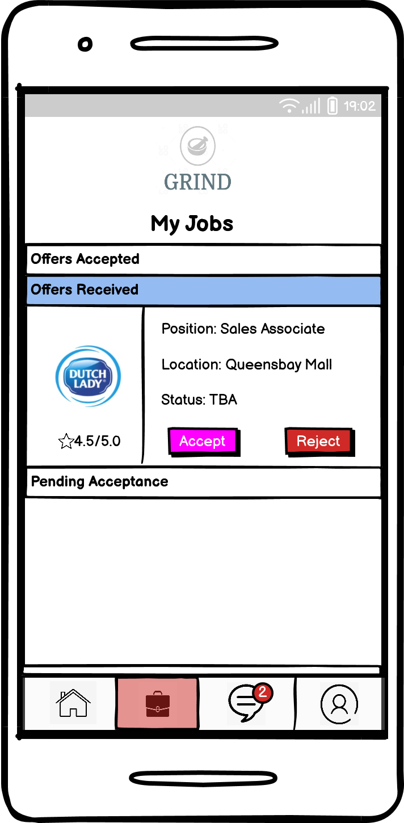

Figure 4.13.2 My Jobs Page (Offers Received)

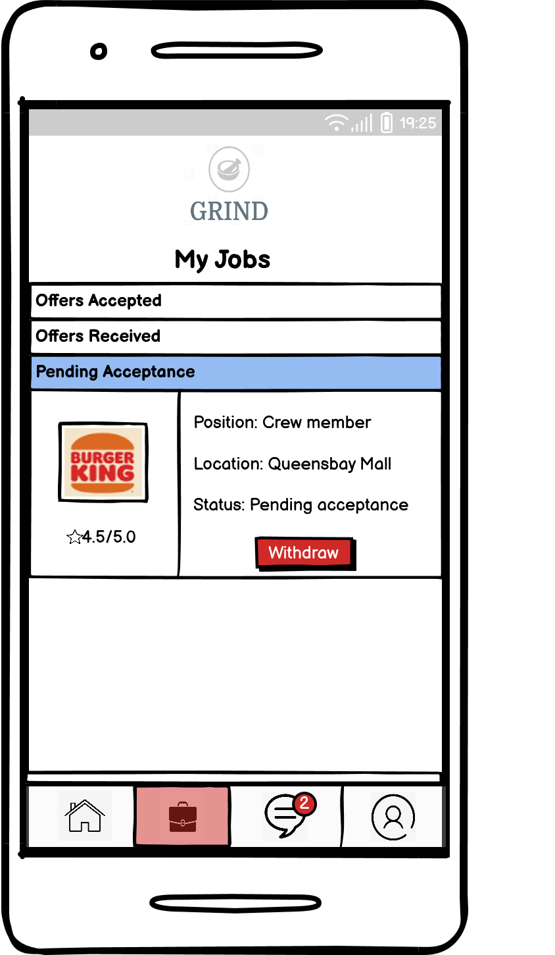

Figure 4.13.3 (Pending Acceptance)

Profile Page

The profile page has several functions.In this page users are able to see the accumulated total earnings and may withdraw these earnings. Besides that, users are also able to view the transaction history for the part-time jobs that they have taken. Several shortcuts are provided to better ease the user in the job finding experience. The settings button at the top right corner allows the user to perform tasks such as changing the user’s privacy details (passwords and bank information), editing profile (personal information) and selecting job preference.

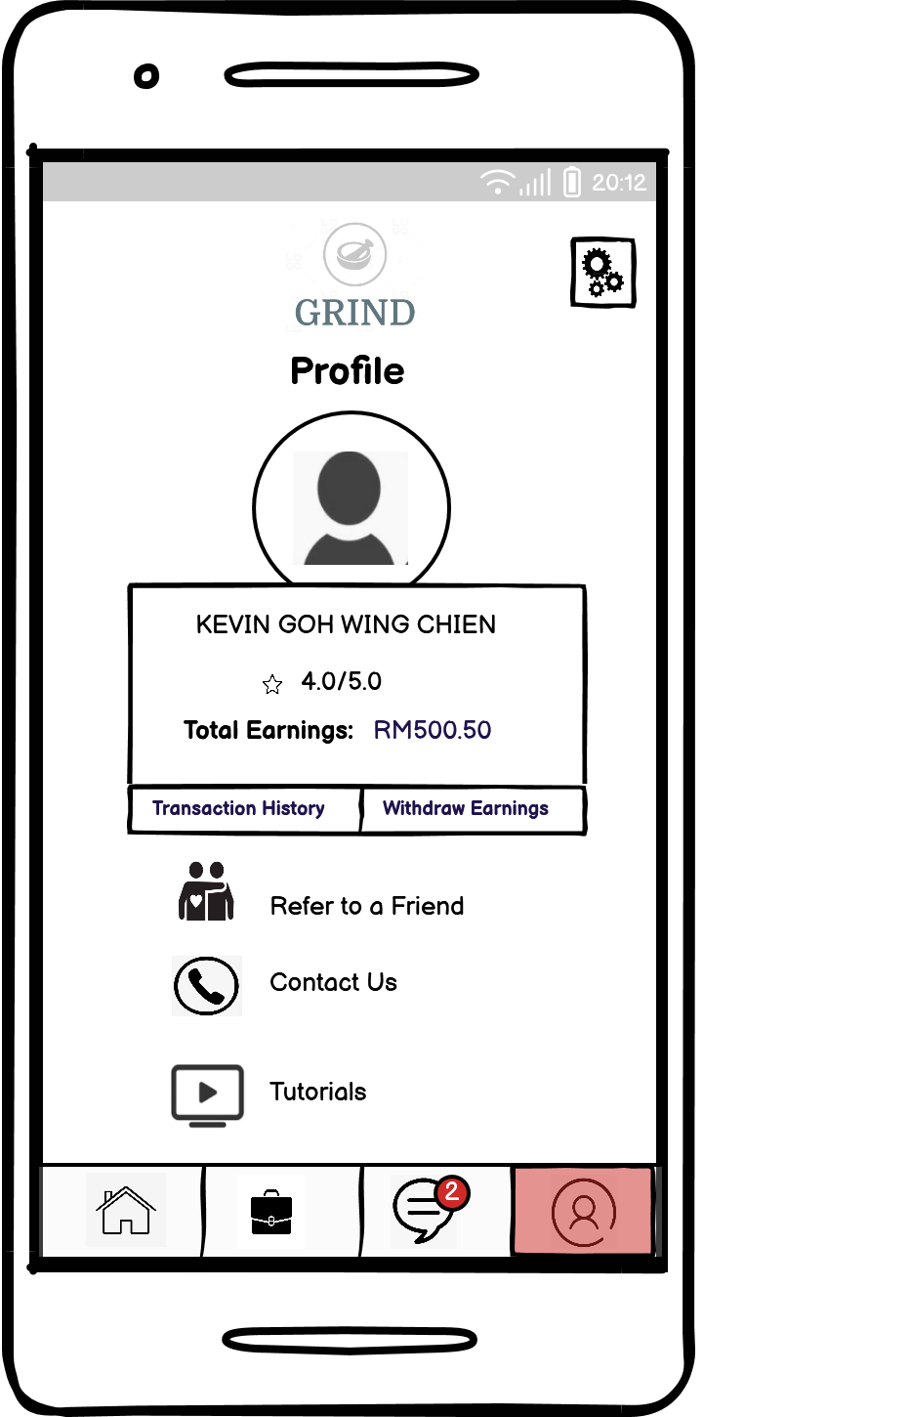

Figure 4.14.1 Profile Page

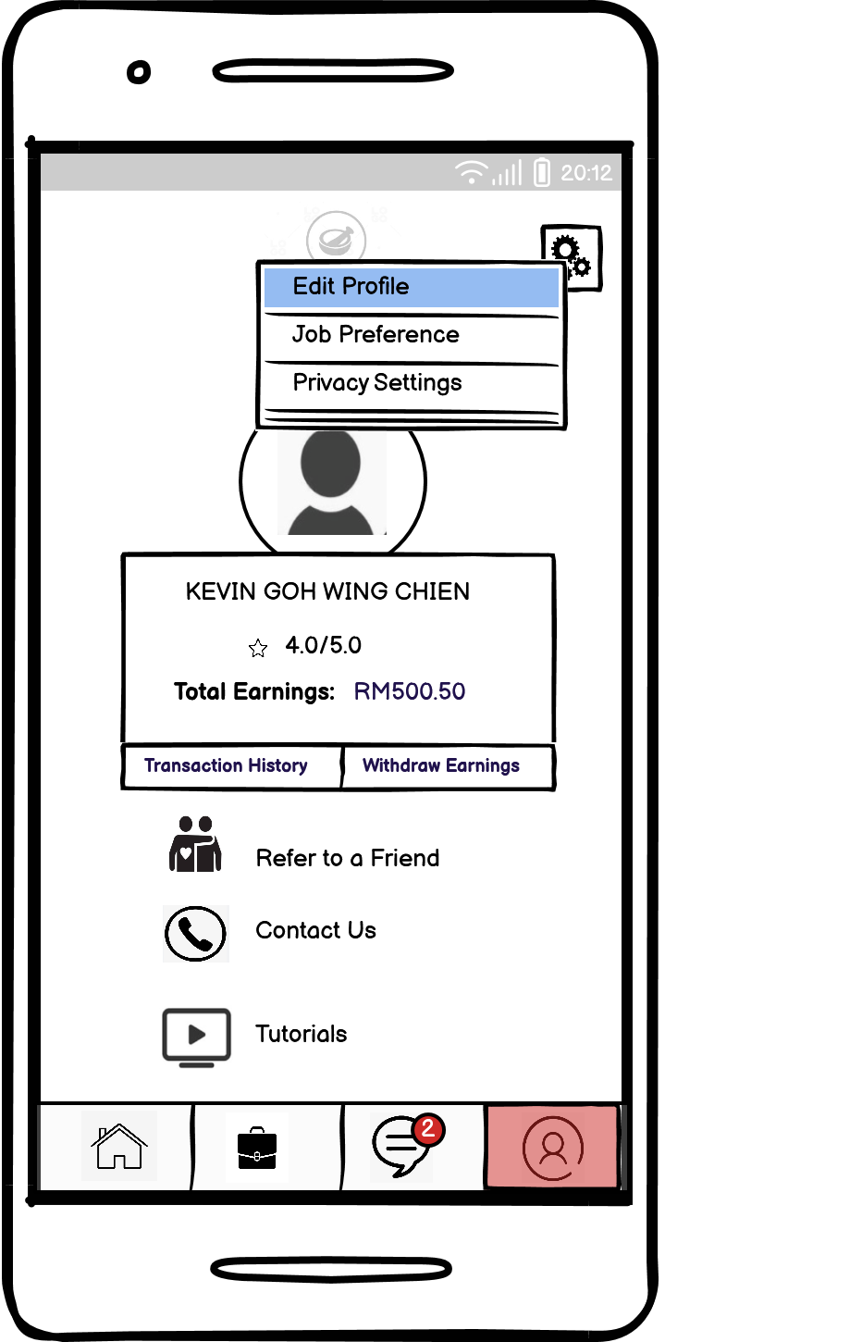

Figure 4.14.2 Profile Page (Settings)

Message Page

All messages from potential employers and Grind’s support team are displayed here. Unread messages are marked in gray. The number inside the red circle of the message button represents the amount of unread messages. Users may reply to the message by simply touching the field within the row. Holding the touch allows users to archive or delete the messages.

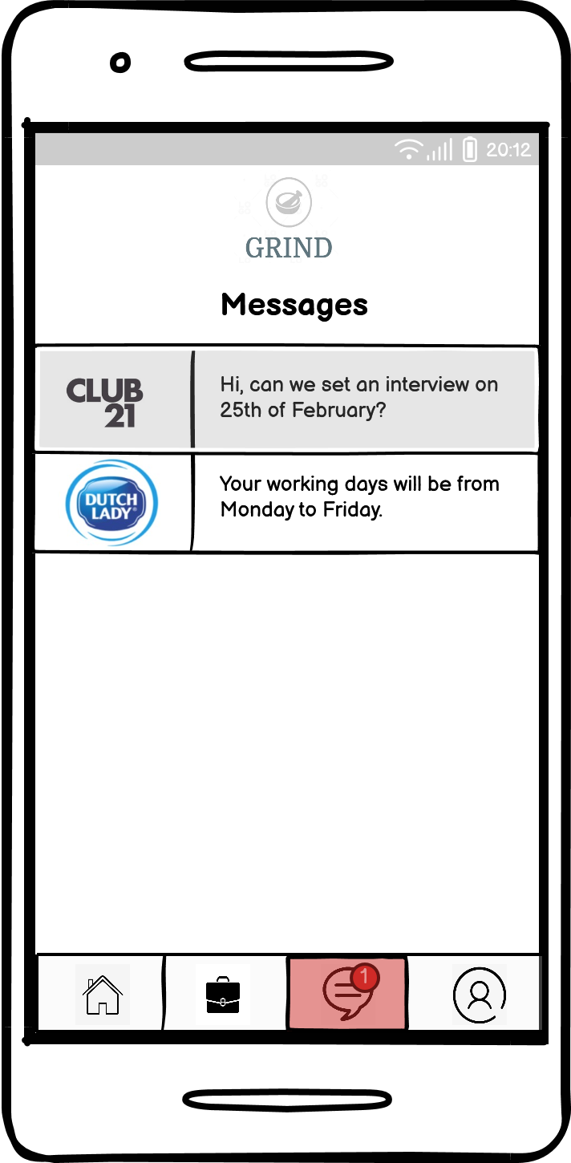

Figure 4.15 Message Page

Privacy Settings Page

Privacy settings page allows the user to modify certain important credentials such as password, bank details, phone number and even email address. Since the application is involved in the transaction of money, a TAC will be sent to the user’s phone every time a change is requested.

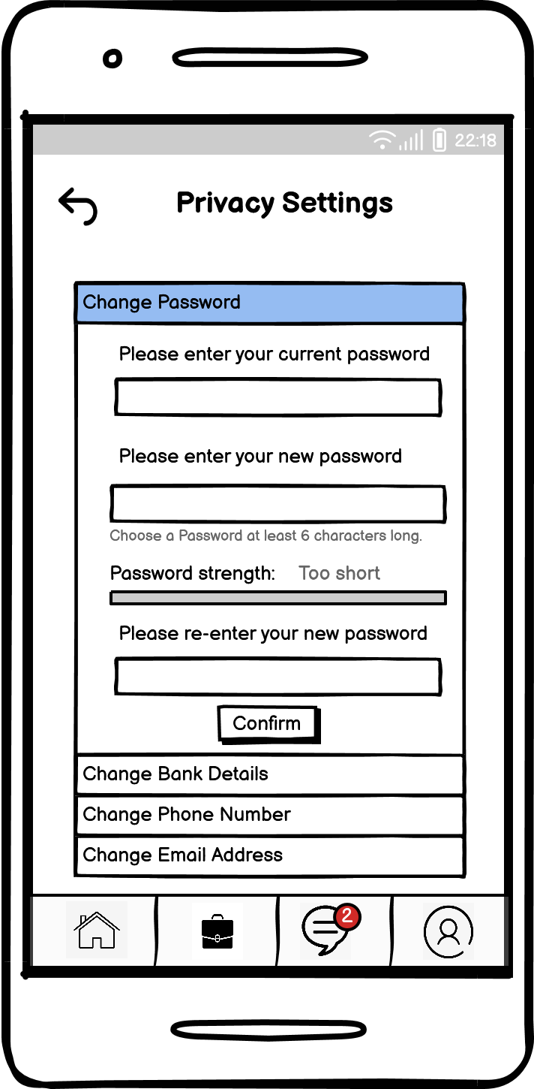

Figure 4.16 Privacy Settings Page

**Technical Understanding**

**Programming Languages**

Java

Java is a high-level language and is also one of the many object-oriented programming languages. This signifies that the code can be reused and is relatively more flexible (Singhal, U., 2022). Besides that, Java is also friendly to amateur developers as Java is relatively easy to learn. Another advantage of Java is that Java is platform independent. Java means that Java can run on virtually any machine regardless of the machine’s operating system.

However Java has some drawbacks too. When compared to other languages such as C or C++, Java is relatively slower. This is because Java interprets and compiles the code at the same time. Besides that, Java’s GUI is also boring as Java is unable to build complex UI.

Kotlin

Kotlin is a general purpose programming language that behaves as an alternative to Java. While the code of Kotlin is able to operate on Java Virtual Machine, the syntax however is not compliant with Java (Ajas, 2022). One of the advantages of Kotlin is that Kotlin is easy to learn, Kotlin even has a smaller learning curve than Java. This is due to much focus being put into enhancing the features to be more reliable. Kotlin is also able to increase the developer’s productivity. This is because the syntax of Kotlin is simple and powerful.

Despite that, Kotlin has some disadvantages too. While in some circumstances Kotlin works faster than Java, however Kotlin is relatively slower when it comes to compilation. Besides that, Kotlin is unable to operate independently. More often than not, Kotlin has to be used alongside Java.

C

C language is the predecessor of C++. However, unlike other languages, C is a procedure-oriented language or a machine language. The advantages of C include that the language is simple and beginner friendly. Besides that, C is also an efficient language. As C contains a huge amount of data types and operators, this allows the developer to perform a variety of operations on a single platform. The efficiency of C language will result in improved runtime performance. Besides that, C is also a portable language. This means that C can be run on any machine with little to no changes.

Despite that, C has several disadvantages too. One of the major disadvantages include the lack of OOP concepts. This signifies that concepts such as data encapsulation and abstraction cannot be utilized in C. C is also more prone to errors as the language lacks a strict type checking.

C++

C++ refers to one of the oldest programming languages in the world. Similar to Java, C++ is also an object oriented language. This signifies that C++ contains certain concepts that allow code reusability, making C++ a more reliable language. Besides that, C++ is also closely related to C. This enables C++ to manipulate low-level data at some level. C++ also has great scalability. This means that C++ is able to run on data of any size.

However C++ also has some disadvantages. C++ is a relatively more difficult language as the concept of pointers in C++ might be difficult to grasp. Systems may behave anomalously or crash if pointers are misused. C++ is also less flexible in the sense that C++ is very strict when it comes to syntax. A mistake in the syntax may cause a series of errors. Besides that, C++ is also relatively unsafe as pointers in C++ allow access to memory locations.

| Java | Advantages   * Allows code reusability * Platform independent * Cheap to maintain * Highly portable |
| --- | --- |
| * Relatively slower * Poor GUI |
| Kotlin | Advantages   * Beginner friendly * Less error prone * Reliable * Efficient and productive * Better GUI than Java * Has most of Java’s advantage |
| Disadvantages   * Unable to operate independently * Compilation slower than Java |
| C | Advantages   * Easy to use * Efficient * Improved runtime performance * Portable |
| Disadvantages   * Lack of OOP * Prone to errors |
| C++ | Advantages   * Allows code reusability * Capability to manipulate low-level data * Great Scalability |
| Disadvantages   * Less secure * System may crash if pointers are misused * Less flexible * Difficult for beginners |

**Selection of Programming Language**

Kotlin is selected as the main programming language to develop Grind. The main reason for that is Grind’s emphasis on security and processing speed. Not only does Kotlin have relatively better security than C and C++, Kotlin is also faster than Java in most circumstances. Besides that, Kotlin is also efficient and has a better GUI than Java. While Kotlin has some flaws, the flaws do not pose much threat to the day-to-day operations of Grind. The reason Kotlin is selected instead of other alternatives due to the advantages that Kotlin brings outweigh the flaws.

**Database**

A database is important for keeping data in an application. Without a database there will be difficulties in updating or changing the existing data. This is because the data would need to be hardcoded into the programme. In addition, a database makes it possible for several people to view and modify the data, which is crucial for collaboration.

PostgreSQL

According to earlier StackOverflow annual surveys, PostgreSQL’s popularity among professional developers has been steadily rising for a few years. According to a user at StackOverflow, the advantages of PostgreSQL include contemporary database features that go well beyond the basic knowledge of databases that are typically required. PostgreSQL is also claimed to have greater support from a committed developer community. PostgreSQL’s strictness allows the DBMS to be relatively less buggy, resulting in substantially more efficient and scalable database operations. In addition to that, PostgreSQL also operates under an open-source environment. This signifies that potential developers have a multitude of tools that are free to work with. However PostgreSQL is not available for Android operating systems.

MySQL

When it comes to RDBMS suppliers, MySQL is a titan. Being ubiquitous in the technology we use every day, MySQL outpaces most others when it comes to widespread adoption. WordPress and other content management systems depend on MySQL engines. Also, a sizable segment of this group are software developers who use web-based technologies. When it comes to ease of use, MySQL Workbench gives beginning developers alternatives to quickly visualize and create, read, update, and delete connected databases. Many tools are available for MySQL that aid in the design of the database architecture.

SQLite

If you're looking for a simple database solution, SQLite and its most recent version can help. Using SQLite, developers can avoid programming the actual server connection establishment required for alternatives like PostgreSQL and MySQL when working on smaller-scale projects where an RDBMS option is required. SQLite's slogan is "Small, Quick, and Dependable." This can be ascribed to the fact that SQLite is an embedded SQL database engine, which essentially means that it offers all of SQL's features in a cross-platform database file that is readily accessible on the local computer. This makes SQLite an extremely portable and light-weight substitute (sqlite.org, 2022). Due to its continued use around the globe and the creators' dedication to keeping it open-source and backwards-compatible, SQLite is a database that enjoys strong community support.

Oracle

Arguably the world’s most popular database management system is Oracle. Oracle processes data efficiently and uses up less space. Oracle can be considered as the most adaptable and economical method of managing confidential data and software. Oracle is compatible with most operating systems and due to its backward compatibility, customers do not have to worry about losing any data (Sullivan, D., n.d.).

| PostgreSQL | Advantages   * Extremely durable database engine * Broad scalability for processing huge data * Fewer bugs in long-term implementation * Open-source and without any other fees * Outstanding community support |
| --- | --- |
| Disadvantages   * Difficult for beginners * Not available for Android OS * Relatively slower reading speed |
| MySQL | Advantages   * Compatible with a huge variety of database tools * Open-source, however MySQL requires a proprietary licenses for businesses * Widely used by large companies * Contains user-friendly tool to help beginners |
| Disadvantages   * Inefficient when it comes to a huge database size (Gupta, A., 2021). * Stored procedures are hard to debug * Developers may have hard time cope with MySQL’s syntax due to being not fully SQL compliant |
| SQLite | Advantages   * Able to read, create, delete or update data locally on the disk++ * Does not require to install * High portability * Accessible through a wide range of tools from outside sources. * Very lightweight and not resource-heavy. |
| Disadvantages   * Restriction of database size (Up to 2GB) * Lack of multi-user capabilities (Yigal, A., n.d.) * Shortness of DBaaS (Database as a Service offering) from popular cloud provider |
| Oracle | Advantages   * Provides high level of security  Relatively fast data processing speed  * Provides backup and auto recovery function * Secure and stable * Reliable * Wide developer community |
| Disadvantages   * Extensive SQL knowledge is required * License is relatively expensive |

**Database Selection**

Oracle will be chosen as Grind’s database management system. The main reason why Oracle was chosen is due to Oracle’s high level of security and fast data processing speed. The alternatives to Oracle do not seem so appealing as most of them have some flaws when it comes to processing huge database size or have a relatively slower processing speed. Since Grind will be dealing with monetary transactions and personal information, security is of utmost importance. Data processing speed is also essential, because a slow and laggy experience will lead to customer frustration, especially when Grind is dealing with productivity.

**References**

1. Scott, B., Lawrence, J., Michael D. 2017.Fundamentals of Investing. 13th ed. England: Pearson Education.
2. World Government Bonds. Malaysia Government Bonds - Yield Curve. (2023, February 19). Available at: <http://www.worldgovernmentbonds.com/country/malaysia/#:~:text=The%20Malaysia%2010Y%20Government%20Bond,last%20modification%20in%20November%202022>). (Accessed 19 February 2023)
3. The World Bank. Part Time Employment, total (% of total employment) - Malaysia (2022, December 6). Available at: <https://data.worldbank.org/indicator/SL.TLF.PART.ZS?end=2019&locations=MY&start=2009&view=chart>. (Accessed 19 February 2023)
4. Fareez Shah & Partners. Employment of Children and Young Person. Available at: <https://fareezlaw.com/employment-law/employment-of-children-and-young-person/>. (Accessed 19 February 2023)
5. Azereen Azmi (2022, December 28). What Does The New Minimum Wage Mean For You. Available at: https://www.imoney.my/articles/malaysia-new-minimum-wage. (Accessed 21 February 2023)
6. Solomon, J. (2022, December 28). The Pros and Cons of Freemium Business Model. Available at: https://www.chargebee.com/blog/freemium-pros-cons. (Accessed 20 February 2023)
7. Vidal, F. (2019, June 29). How to Implement a Smart Commission Pricing Model for Marketplace Businesses. Available at: https://www.shopery.com/insights/marketplace-commission-models. (Accessed 20 February 2023)
8. GoCardless. (2019, June 29). Subscription Business Model Pros and Cons. Available at: https://gocardless.com/guides/posts/pro-cons-subscription-business-model/. (Accessed 20 February 2023)
9. Shafer, E. (n.d.). Why Physical Advertising is Still Important. Available at: <https://www.indoormedia.com/blog/why-physical-advertising-is-still-important#:~:text=What%20is%20traditional%20advertising%3F,see%20billboard%20advertising%20in%20action>. (Accessed 20 February 2023)
10. Matthew, J. (2018, July 30). Understanding Influencer Marketing and Why It Is So Effective. Available at :https://www.forbes.com/sites/theyec/2018/07/30/understanding-influencer-marketing-and-why-it-is-so-effective/?sh=4c2db28371a9. (Accessed 20 February 2023)
11. Patel, S. (2021, November 25). 3 Referral Marketing Strategies That Earn You More Customers. Available at:<https://www.wordstream.com/blog/ws/2019/05/06/referral-marketing>. (Accessed 20 February 2023)
12. Hong, P. (2022, September 27). Apple Is Expected To Break The Record For The Average iPhone Price. Available at https://vietnaminsider.vn/apple-is-expected-to-break-the-record-for-the-average-iphone-price/. (Accessed 10 February 2023)
13. Deed, I. (2023, January 24). How Much Does an iOS App Cost? Available at: <https://www.pangea.ai/ios-app-dev-company/how-much-does-an-ios-app-cost/#:~:text=A%20developer%20license%2C%20required%20to,hardware%20used%20to%20build%20code>. (Accessed 10 February 2023)
14. Bagott, A. (2023, January 8). Every Apple App Store Fee, Explained: How Much, For What, and When. Available at: https://appleinsider.com/articles/23/01/08/the-cost-of-doing-business-apples-app-store-fees-explained. (Accessed 10 February 2023)
15. Girdhar, A. (2022, January 7). How Much Does a Google & Apple Developer Account Cost? Available at: <https://www.appypie.com/faqs/how-much-does-a-googleapple-developer-account-cost>. (Accessed 10 February 2023)
16. Szczygiel, B. (2022, December 13). iPhone vs Android Users: Key Differences. Available at: https://www.netguru.com/blog/iphone-vs-android-users-differences. (Accessed 12 February 2023)
17. Advantages and Disadvantages of iOS, (2021) Digital Aptech Private Limited. Available at: <https://www.digitalaptech.com/advantages-and-disadvantages-of-ios/>. (Accessed 12 February 2023)
18. McDonald, T. (2021, April 8). Comparison Between Open Source and Closed Source Software. Available at:https://www.nsiserv.com/blog/bid/29956/comparison-between-open-source-and-closed-source-software. (Accessed 13 February 2023)
19. Lawrence, N. (2020). UI/UX Design Simplicity. Available at: <https://uxplanet.org/ui-ux-design-simplicity-f1cbfbfffb4b>. (Accessed 21 February 2023)
20. Soegaard, M. (2021). The Power of White Space in Design. Available at:[*https://www.interaction-design.org/literature/article/the-power-of-white-space*](https://www.interaction-design.org/literature/article/the-power-of-white-space)*.* (Accessed: 19 January 2023).
21. Boag, P. (2011). Why whitespace matter. Available at: <https://boagworld.com/design/why-whitespace-matters/>. (Accessed: 18 February 2023).
22. Green, D. (2015). The Importance of Simplicity in User Interface (UI) Design. Available at: <https://einsights.com/the-importance-of-simplicity-in-user-interface-ui-design/>. (Accessed: 19 February 2023).
23. Tidwell, J. (2011). Designing Interfaces, 2nd edn, O'Reilly Media, Canada.
24. Chin, Z. (2020). Sudden Changes in UI: Why It's a Bad Move. Available at: <https://blog.snappymob.com/sudden-changes-in-ui-why-its-a-bad-move>. (Accessed: 18 February 2023).
25. Gupta, A. (2021, September 27). PostgreSQL vs MySQL: Know the Major Differences. Available at: https://www.simplilearn.com/tutorials/sql-tutorial/postgresql-vs-mysql. (Accessed: 18 February 2023).
26. Sullivan, D. (n.d.). Advantages & Disadvantages of Oracle SQL. Available at: https://www.techwalla.com/articles/advantages-disadvantages-of-oracle-sql. (Accessed: 18 February 2023).
27. Singhal, U. (2022, Dec 13). Advantages and Disadvantages of Java Programming Language. Available at: https://unstop.com/blog/advantages-and-disadvantages-of-java. (Accessed: 18 February 2023).
28. Ajas, (2022, September 27). Advantages and Disadvantages of Kotlin. Available at: <https://www.techquintal.com/advantages-and-disadvantages-of-kotlin>. (Accessed: 18 February 2023).

Competitor’s Pricing Plan

**Trooper**

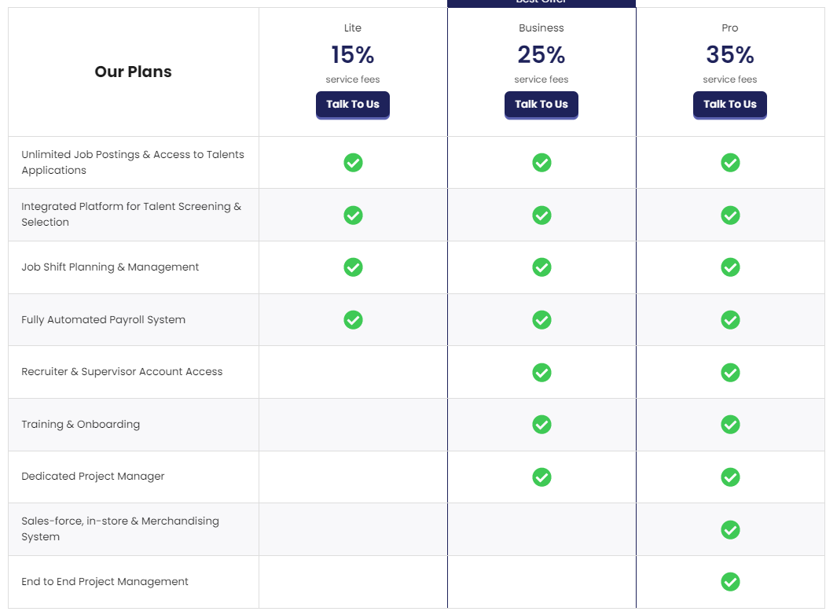

**Indeed**

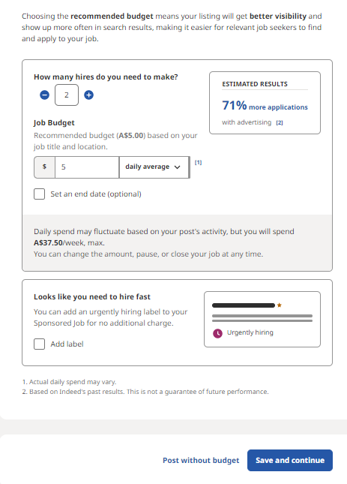

**JobStreet**

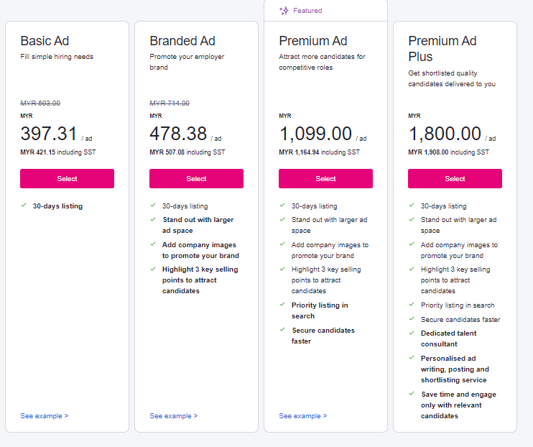

**A101SGI Grading Rubric for Report**

|  | **0** | **3** | **6** | **9** | **12** | **15** |
| --- | --- | --- | --- | --- | --- | --- |
| **Business Opportunity**  **LO1 20%** | No business opportunity has been defined | An idea has been proposed but it has not been thought through | There has been an attempt to describe a potential business opportunity but this is not backed by any evidence | The app proposed is justified with a good business case however there is a lack of evidence to back this up | Strong app idea backed with evidence showing potential audience and market share | There is clearly defined business opportunity which has been justified using appropriate, up-to-date information |
| **Marketing and Sales LO1**  **20%** | There is no strategy for marketing and sales | Very simple marketing plan proposed with inappropriate sales and income targets | Simple marketing plan proposed without justification but this does not include details such as costing | A marketing plan shows both a marketing plan plus suggested sales, costings and income | A marketing plan that shows both a feasible marketing plan and realistic sales, costings and income | Detailed market research that supports the business opportunity including the use of market segmentation to focus marketing and development |
| **Platform Analysis LO2**  **20%** | No explanation of the choice of platform(s) | Basic understanding of the platform differences without reference to the proposed app | A choice has been described however there is no justification given for the choice | Clear, justified choice for the platform(s) chosen including a convincing financial argument | Clear, detailed argument based on the strengths and weaknesses of the different platforms market share and target audience | Careful analysis of the market share and a clearly justified choice based on target audience and specific platforms versions |
| **Design LO2 20%** | No app designs presented | Very simple apps designs shown that don’t demonstrate the core functionality | Design demonstrated for the basic app’s functionality but fails to comply with platform specific HIGs | A complete design that uses the standard UI elements and complies with platform HIG | A complete design that both uses custom UI elements and animations yet fully complies with the platform HIG | A professional standard detailed app design that covers all functionality and fully complies with the platform(s) HIG. |
| **Technical Understanding**  **LO3 20%** | No technical understanding shown | Some basic understanding of how apps are built has been demonstrated | Basic knowledge shown regarding the different development approaches but not related to the proposed app | Understanding of the differences between the different approaches both in terms of features and performance | Detailed understanding of the different development approaches and their capabilities and performance | Clear understanding of the pros and cons of different development approaches with reference to the proposed app and market |